

|  |
| --- |
| Binh Nguyen |
| Researching and AI Testing Strategies for Video Management System. |
|  |
|  |

|  |
| --- |
| Information and Communication  2023 |
|  |

VAASAN AMMATTIKORKEAKOULU

UNIVERSITY OF APPLIED SCIENCES

Information Technology

**ABSTRACT**

Author Binh Nguyen

Title Researching and AI API Testing for Video Management

System

Year 2023

Language English

Pages 63 + 3 Appendices

Name of Supervisor Kenneth Norrgård

Embark on an insightful exploration of testing strategies for ITD Group’s Smart Video Management System within the context of this thesis. This study delves into the realm where cutting-edge technology converges with boundless information. The Video Management System is simulated employing with Python, facilitating a comprehensive understanding of its intricate working.

This thesis also moves us with the transition from manual testing API into advanced methods like unit testing and real cam Testing. Unveiling the features of AI APIs, system bugs, script tests. Moreover, the thesis will analyze similar video management system like Milestone, Axis for the valuable insights.

With all the above activities, this study illuminates a pathway to be a responsible Software Engineer within the realm of Video Management System.

Keywords Video Management System (VMS), Python, Open Source, Docker, Kubernetes, unit testing, automation, AI APIs, system bugs, script tests, Milestone, Axis.

**CONTENTS**

Tiivistelmä

ABSTRACT

1 IntroDuction 10

1.1 Background of ITD Group’s Smart Video Management System 10

1.2 ITD’s AI description API document (IMPORTANT) 10

2 Literature review 12

2.1 Overview of video management systems with AI capabilities 12

2.2 Best practices for testing and quality assurance in Video Management Systems. 14

2.3 Description of the software and hardware used in the thesis. 16

2.4 Overview of similar Video Management System. 17

2.4.1 VMS MileStone (Milesight). 18

2.4.2 VMS Axis 23

2.5 Conclusion 26

3 simulation of an AI cameara application 27

3.1 Simulation project of an AI training model. 27

3.2 Intrusion Warning Project (With YOLO & OpenCV) 36

3.2.1 What is Intrusion Warning? 36

3.2.2 Building Intrusion Warning System application: 39

3.3 Our Mission 52

4 Testing Stategies (In practice) 53

4.1 Manual Testing with Postman and Unit Testing with Pytest: 53

4.1.1 Manual testing with postman: 54

4.1.2 Unit Testing with Pytest and an example of Scalability testing: 60

4.2 Writing script test for object tracing feature: 68

4.3 Conclusion: 72

5 Conclusion and Future Work. 74

5.1 Contribution to the field of Video Management System with AI capabilities. 74

5.2 Limitations of the thesis and future work. 74

references 75

APPENDICES

**LIST OF FIGURES AND TABLES**

**Figure 1.** Analyse if the detected object is inside the restricted area. p. 13

**Figure 2.** Facial recognition. p. 14

**Figure 3.** Front Page of Milesight VMS. p. 18

**Figure 4.** Camera view of Milesight VMS. p. 22

**Figure 5.** Streaming view of VMS Axis. p. 24

**Figure 6.** file structure for using in training data. p. 28

**Figure 7.** Labelling the image dataset for supervised learning. p. 28

**Figure 8.** Configuration for labelling task. p. 29

**Figure 9.** Opening the task project for labelling. p. 30

**Figure 10.** Going to the job#[id] for labelling. p. 30

**Figure 11.** Labelling the objects manually. p. 30

**Figure 12.** Exporting labelled dataset. p. 31

**Figure 13.** Modifying the export format into YOLO1.1. p. 31

**Figure 14.** obj_train_data in the person.zip that we exported. p. 32

**Figure 15.** Start the Google Collab and connect to Google Drive. p. 32

**Figure 16.** Connecting Google Drive after running the above code. p. 33

**Figure 17.** Mounting to Google Drive successfully. p. 33

**Figure 18.** Installing ultralytics library in Google Collab Python notebook. p. 34

**Figure 19.** Importing os module to interact with the operating system. p. 35

**Figure 20.** Workflow of Intrusion Warning project. p. 37

**Figure 21.** Pipeline of the Intrusion Warning project. p. 38

**Figure 22.** Centroid of human example. p. 39

**Figure 23.** Activating conda virtual environment. p. 40

**Figure 24.** Required external libraries for our project. p. 40

**Figure 25.** Use project to turn on webcam. p. 41

**Figure 26.** Pre-trained model folder. p. 42

**Figure 27.** Importing libraries for file **“yolodetect.py”.** p. 43

**Figure 28.** Define **“isInside”** function. p. 43

**Figure 29.** Defines a class **“YoloDetect”** class for object detection. p. 44

**Figure 30.** Define **“read_class_file”** function in the **“YoloDetect”** class. p. 44

**Figure 31.** Define **“get_output_layers”** function in the **“YoloDetect”** class. p. 44

**Figure 32.** Define **“draw_prediction”** function in the **“YoloDetect”** class. p. 45

**Figure 33.** Declaring variables **"label**" and **"color"** inside the **“draw_prediction”** function. p. 45

**Figure 34.** Declaring variables for Calculating the coordinates inside the **“draw_prediction”** function. p. 46

**Figure 35.** Declaring variables for Calculating the bounding box inside the **“draw_prediction”** function. p. 46

**Figure 36.** Drawing the bounding box inside the **“draw_prediction”** function. p. 47

**Figure 37.** Calculating the centroid point. p. 47

**Figure 38.** Conditional statement for sound alerting. p. 48

**Figure 39.** Define **“alert”** function in the **“YoloDetect”** class. p. 48

**Figure 40.** Define “detect” function in the “YoloDetect” class. p. 49

**Figure 41.** Modifying the **"telegram_utils.py"** file p. 50

**Figure 42.** Detected person inside the restricted area successfully. p. 51

**Figure 43.** Our Intrusion Warning system sends telegram warning message successfully. p. 51

**Figure 44.** Register a face to ITD's database successfully. p. 55

**Figure 45.** Create a Workspace for our project, here I created one named Isecurity. p. 57

**Figure 46.** Allocating each API into separate collections with Postman. p. 57

**Figure 47.** Setting up the url environment with Postman. p. 58

**Figure 48.** Shortcut for url address we use after setting up url environment for example **{{name_of_url}}**. p. 58

**Figure 49.** Set request format as JSON in Postman. p. 59

**Figure 50.** Delete the base64 data tag before comma `,`. p. 59

**Figure 51.** Libraries for Unit Testing with Postman. p. 61

**Figure 52.** Declaring the variables for API url. p. 61

**Figure 53.** Define a function for decoding our images into Base64. Simultaneously, declare base64 image variables. p. 61

**Figure 54.** Declare template data variables p. 62

**Figure 55.** Test case registering a cat into the face recognition system. p. 63

**Figure 56.** CLI command for test our test case p. 63

**Figure 57.** Folder structure for scalability test p. 64

**Figure 58.** Declare different face list for scalability test. p. 64

**Figure 59.** Import libraries and define API endpoint. p. 65

**Figure 60.** Define encodeToBase64Img function for scalability testing. p. 65

**Figure 61.** Define `test_registration_multiple_faces` function for scalability testing. p. 66

**Figure 62.** Define `test_update_multiple_faces` function for scalability testing. p. 67

**Figure 63.** Define `test_delete_multiple_faces` function for scalability testing. p. 68

**LIST OF APPENDICES**

**APPENDIX 1.** Thesis passport

**APPENDIX 2:** Appendices

**APPENDIX 3.** Thesis assessment criteria

IntroDuction

## Background of ITD Group’s Smart Video Management System

ITD Group is at the fore of innovative efforts as Vietnam approaches a crucial turning point in its digital transformation in 2023. ITD group has worked on many initiatives as part of its commitment to digital transformation that have transformed business practices in Vietnam and elsewhere, including the creation of a smart camera management system. This system holds great potential in various domains such as time attendance management, building security, road traffic system, monitoring, and highways, offering highly efficient solutions for this area.

The comprehensive nature of the Video Management System project is extensive, as it is built using a microservice architecture. Currently, during the writing of this thesis, the project is still in progress and involves several distinct scopes, including the backend, backend API, AI training model (YOLO v8 currently), API of AI, and various frontend modules for administrator…

However, this thesis specifically focuses on in-depth testing of AI APIs for supporting improving recognition features purpose such as Face recognition, Person detection, writing script test for end user of object tracking feature. Additionally, it delves into VMS research, providing valuable references for the development of ITD Group’s product as well as provide a strong point of view in how to make a pilot project related AI video management system which is a helpful knowledge for people who would like to become an AI testing engineer in the near future.

The thesis’s scope is related to AI, Data, and research. Therefore, there would be too many images and figures provided, it requires the readers to be patient for having a trip up to down sequentially.

## ITD’s AI description API document (IMPORTANT)

First and foremost, it is necessary to check out the [link here](https://github.com/tripplen23/thesis/blob/main/thesis_report/APIDescriptionDocument.docx) for the AI API Documentation in English version (Which I had honor to be a part of editor).

Read and carefully understand the API document is always the most important in the rule list of any tester. This helps us to know what our system is talking about, how to request and the ways the system response for those requests.

Moreover, reading the API documentation for an AI project is crucial for more reasons such as: Understanding functionality, Integration and Development, Use Cases, Data Requirements, Model Performance, Scalability, Troubleshooting, Security, Cost and Pricing, Updates and Versioning, Legal and Ethical Considerations, Collaboration, …

After knowing the API functionalities that we will work it, let’s do several research related to the AI Camera System industry by moving to the next session where we will expand our vision through the literature review of one of the most important development in the digital transformation era these days.

# Literature review

In this chapter, we explore the World of AI-powered camera systems. We will see how they are used in managing videos, how they’re tested to ensure they work well, and what tools we are using for this study.

To begin, we will look at video management systems that use AI. Then, we will learn about the testing methods to ensure these systems are reliable as well as the software and hardware we are using.

Lastly, we will peek at similar Video Management Systems like Milestone or Axis. This chapter sets the stage for our deeper dive into how AI is impacting video management.

This chapter lays the foundation for understanding AI camera systems and their impact on Video management.

## Overview of video management systems with AI capabilities

Video management system (VMS) are software platforms designed to manage, record, and analyse video footage from surveillance cameras. The integration of Artificial Intelligence (AI) within VMS has significantly transformed the landscape of video surveillance by enabling advanced functionalities that go beyond traditional video management. AI-powered VMS leverages machine learning algorithms to process and understand video data, offering enhanced security, operational efficiency, and actionable insights.

* **Concept 1: AI-enhanced Video Analysis**

Real-time video analysis, including object detection, tracking, and recognition, is made possible by AI using VMS. With the use of these abilities, VMS can recognise and classify objects, people, vehicles, and events inside video streams. For instance, AI can watch suspicious conduct, monitor crowd density, detect unauthorised access, and more.

* **Concept 2: Predictive Analytics and Anomaly Detection**

A VMS with AI integration can predict security breaches by looking at past data and seeing trends. Alerts can be sent out when anomaly detection algorithms spot odd behaviour or events. By addressing possible dangers prior to them becoming more serious, this proactive strategy improves security.

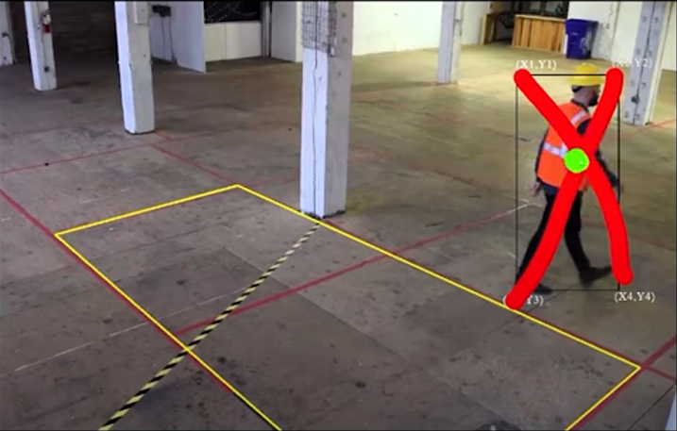

Figure 1. Analyse if the detected object is inside the restricted area.

* **Concept 3: Automated Alerts and Notifications**

Based on established parameters, AI-powered VMS can automatically produce alerts and notifications. This function guarantees quick response to serious occurrences. Security professionals can receive alerts via email or mobile apps, allowing them to take prompt action.

Image: Screenshot of a mobile app notification alerting the user to a security event detected by an AI-enhanced VMS.

* **Concept 4: Face Recognition and Biometric Analysis**

Identification and verification of people are made possible by the integration of facial recognition technology into VMS. This helps with visitor management, access control, and strengthening security procedures.

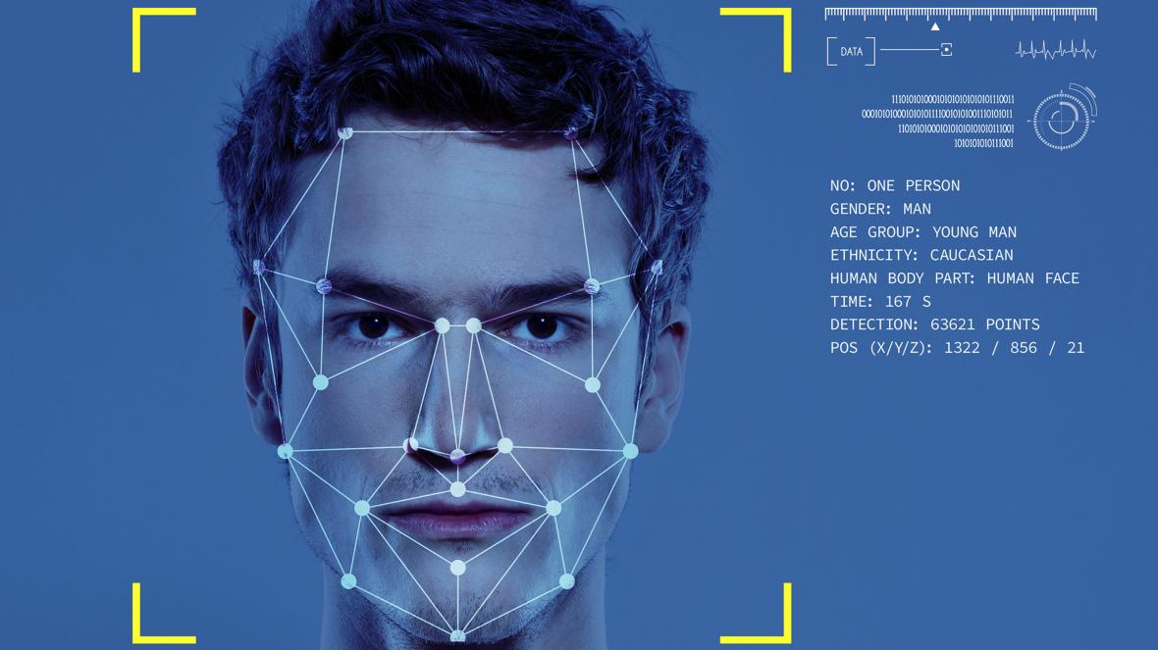

Figure 2. Facial recognition.

* **Concept 5: Data-driven insights for Decision Making.**

AI-driven VMS can extract useful information from video footage to support decision-making. The layout of stores and marketing tactics, for instance, can be improved by studying client mobility patterns in retail settings.

## Best practices for testing and quality assurance in Video Management Systems.

To ensure the dependability and effectiveness of video management systems (VMS) with AI capabilities, stringent testing and quality assurance practices are required. Thorough testing ensures that the system works properly, delivering accurate insights and secure monitoring. This section goes into the important best practices used in AI-infused VMS testing and quality assurance.

* **Concept 1: Understanding the project documentation**

As this thesis mentioned before, understanding the project documentation provides a solid basis. Understanding the system's architecture, technical specification, and expected functionality are all part of this. Clear project documentation establishes the context required for effective testing and quality assurance initiatives.

As an AI Test engineer, at some companies this is also our responsibility to become one of the editors for those project documentations.

* **Concept 2: Understanding the project**

As a swimming class, we need to know firstly the survive way in our working environment. Let’s take a deep dive into how the system work, how to fetch camera from its IP address, RTSP (Real Time Streaming Protocol), how to connect it with our company API, how to connect the AI System Camera into our personal machine (Laptop, PC), how to draw on it for testing the AI by using OpenCV library, …

If you are a beginner, do not hesitate to bother your boss or senior about those doubts, this concept is important. Just think that you need to clarify what is having and what is not having in your company’s project to enhance those functionalities or make some more technical debt reports to your team.

* **Concept 3: Unit Testing and Automation Testing**

To ensure that the backend of AI VMS functions work well, it is vital to ensure that the AI API functions as expected. During the development process, we could employ a variety of technical tools, such as Postman and pytest. If there is a system bug, AI testing engineers must be responsible for providing feedback to both the AI team and the IT team as soon as possible. In other words, as AI testing engineers, we should serve as a link between our company's AI and IT departments.

Automation testing further streamlines this process by automating repetitive test script being executed using testing tools (E.g., Selenium, pytest, unittest, nose2, tox, …).

* **Concept 4: Comprehensive Testing Framework**

An effective testing framework encompasses functional, performance, and security testing.

Individual aspects such as object detection and alert generating are evaluated during functional testing. System reaction times are measured during performance testing under changing loads, assuring responsiveness even during peak usage. Security testing detects flaws that could be exploited.

* **Concept 5: Chaos Testing**

The process of deliberately putting a system to stressful and unexpected conditions is known as chaos testing. This is critical for robustness since it checks the system's resilience, fault tolerance, and capacity to recover gracefully from faults.

Chaos Testing is normally gone with a big project which is structed as microservice structure. The testing idea is turning off one of the microservice but still ensure that the other services as well as the whole system are still working.

[Here](https://www.harness.io/blog/chaos-engineering-tools#:~:text=Netflix%E2%80%99s%20Chaos%20Monkey%20is%20an%20open-source%20chaos%20engineering,The%20software%20functions%20by%20implementing%20continuous%20unpredictable%20attacks.) is the list of the top chaos engineering tools.

* **Concept 6: User Acceptance Testing (UAT)**

End-users evaluate the system's usability and functioning during user acceptance testing. Real-world user feedback assists in finding areas for improvement and aligning the system with realistic requirements.

As a test engineer, “putting ourselves in the shoes of the end user” is something worth paying attention to.

## Description of the software and hardware used in the thesis.

This section provides an overview of the software and hardware components used in the thesis project's execution.

* **Software Utilized:**

**Python:** Python, a versatile programming language, acts as the foundation for the AI-powered video management system's development. Python's numerous libraries and frameworks enable rapid data handling and AI algorithm integration.

**OpenCV:** OpenCV (Open Source Computer Vision Library) is a critical tool for image and video analysis. Its capabilities are used within the AI-infused video management system to process video streams, detect objects, and perform other analysis.

**Pytest:** To automate testing operations, Pytest, a popular testing framework, is used. Its simplicity and extensibility simplify the validation of numerous system functionalities.

**Postman:** Postman, a popular API testing tool, assists in testing the AI API's functioning. Its user-friendly UI makes it easier to validate API endpoints and answers.

**Github:** The collaborative platform GitHub is essential for version control and project management. It ensures team members' smooth communication, version tracking, and the availability of the codebase.

**Yolov3:** A pre-trained AI model which contains several class names for label defined before, such as: person, bird, phone, … objects.

**Yolov8:** Using the powerful opensource for training a new model.

**Telegram:** An application which is helpful for API integration for our simulation demo project.

**IDE:** Visual Studio Code (For building a simulation), Google Collab (For training an AI model).

* **Hardware Utilized:** Security Camera at ITD company, Laptop Webcam.

## Overview of similar Video Management System.

As an AI test engineer, it is important to learn the existing features of other video management systems, which allows us to add more to the current perspective, thereby integrating more. More features for the existing camera system of our business. In this section, we will focus mainly on some research on VMS MileStone and VMS Axis.

### VMS MileStone (Milesight).

Milesight VMS is a video management system designed for using in a variety of environments, from small businesses to large scale enterprises.



Figure 3. Front Page of Milesight VMS.

* **System features:**

**- Video Recording and Storage:** Milestone VMS is primarily designed to record and store video footage from surveillance cameras. This app provides secure video recording with various customizable settings like frame rate, resolution, and compression. Up to 8 cameras can be connected at the same time in the free version, but in the more expensive versions, the number will be much larger, possibly up to several thousand cameras.

**- Video analysis:** The software is equipped with advanced video analysis capabilities such as detecting different objects, capturing motion changes, and supporting searching by the above objects.

**- Remote Access:** Milestone VMS allows users to access video footage and analytics from remote locations using a web browser or mobile app. This makes it easy to monitor and manage surveillance activities from anywhere at any time.

**- User Management:** The software comes with a user management module that allows administrators to control access and permissions for each user. It helps ensure that only authorized people can access sensitive video data.

**- Customizable:** The software is highly customizable and can be tailored to meet the specific needs of different organizations. This includes customization of the user interface, video analytics settings, and integration with third-party software.

**- Scalability:** Milestone VMS is designed to handle many cameras and video streams, making it suitable for small to large scale surveillance operations.

**- Reports:** The software provides advanced reporting capabilities that help analyse video data and identify trends. This includes generating reports on video analytics, user access, and system performance.

* **AI Integrated Features:**

Milestone VMS can integrate with a wide range of devices and third-party software such as cameras, access control systems and alarm systems. This provides a seamless and comprehensive security solution for businesses and organizations. Some object detections that Milestone can integrate may be listed as:

**- Motion Detection:** Milestone VMS can detect motion in a specific area of camera view and trigger an alert or recording. It can also distinguish between different types of motion, such as human movement or vehicle movement.

**- Face Recognition:** The software can recognize faces in real time and compare them with a database of known faces to identify individuals. This feature is useful in enhancing security and identifying potential threats.

**- License plate recognition:** Milestone VMS can recognize and read license plates on vehicles and compare them with a database of known license plates to identify the vehicle or follow it. track their movements.

**- Object Detection:** The software can detect and track specific objects in the camera view, such as bags or packages, and trigger alerts or logs based on rules predefined.

**- People Count:** Milestone VMS can count people entering and exiting a specific area, such as a store or building. This feature is useful in managing crowds, analysing purchase data, and improving customer service.

**- Audio Analysis:** The software can analyse audio data from the camera and microphone, and detect specific sounds, such as gunshots or broken glass, and activate alarm or recording.

**- Heat Map:** The software can generate heatmaps showing the frequency and duration of activity in the camera view. This is useful in analysing customer behaviour and optimizing store layouts.

**- Object Classification:** Milestone VMS can classify objects in the camera view based on their size, shape, and motion. This helps to identify specific objects, such as vehicles or people, and trigger alerts or logs based on predefined rules.

**- Anomalous Behaviour Detection:** The software can detect unusual behaviour in the camera view, such as a person loitering in a restricted area or a vehicle driving in the wrong direction. This helps to identify potential threats and increase security. (Intrusion Warning).

**- Mask detection:** Milestone VMS can detect if people in camera view are wearing masks and trigger an alert or record if wearing a mask is required in an area specific area. This feature is useful during the time of COVID-19.

**- Distance monitoring:** The software can monitor and detect if people in the camera's field of view are maintaining a safe distance from each other and trigger an alert or record if the social distancing rules are violated.

**- Disappearance object detection**: Milestone VMS can detect when an object has been removed from a specific area of the camera view, such as a piece of art from the gallery. This helps prevent theft and increases security.

**- Camera tamper detection:** The software can detect when the camera is tampered with, such as being covered or moved, and trigger an alert or record.

**- Queue management:** The software can detect and monitor queues or queues in real time, such as in a retail store or at a ticket counter and generate alerts or notifications. reports to optimize queue management.

**- Perimeter Protection:** Milestone VMS can detect and alert security personnel when someone enters or crosses a predefined perimeter or boundary, such as a fence or wall, to prevent unauthorized access or encroachment.

**- Crowd Detection:** The software can detect and track crowd movements and density in real time, such as during a concert or public event, and create alerts or notifications to manage crowd control.

**- Loitering detection**: Milestone VMS can detect and monitor when someone is loitering in a specific area, such as a parking lot or dock, and generate alerts or notifications to increase security.

**- Fall detection:** The software can detect and track when someone falls, such as in a hospital or nursing home, or especially during Finnish winter and generate alerts or notifications to aid in emergency response.

**- Smoke and fire detection:** Milestone VMS can detect and monitor smoke and fire in real time and generate alerts or notifications to enhance safety and reduce response time in case fire.

- **Facial Emotion Recognition:** The software can detect and analyse facial expressions in real time, such as happy, sad, angry or surprised, and at the same time.

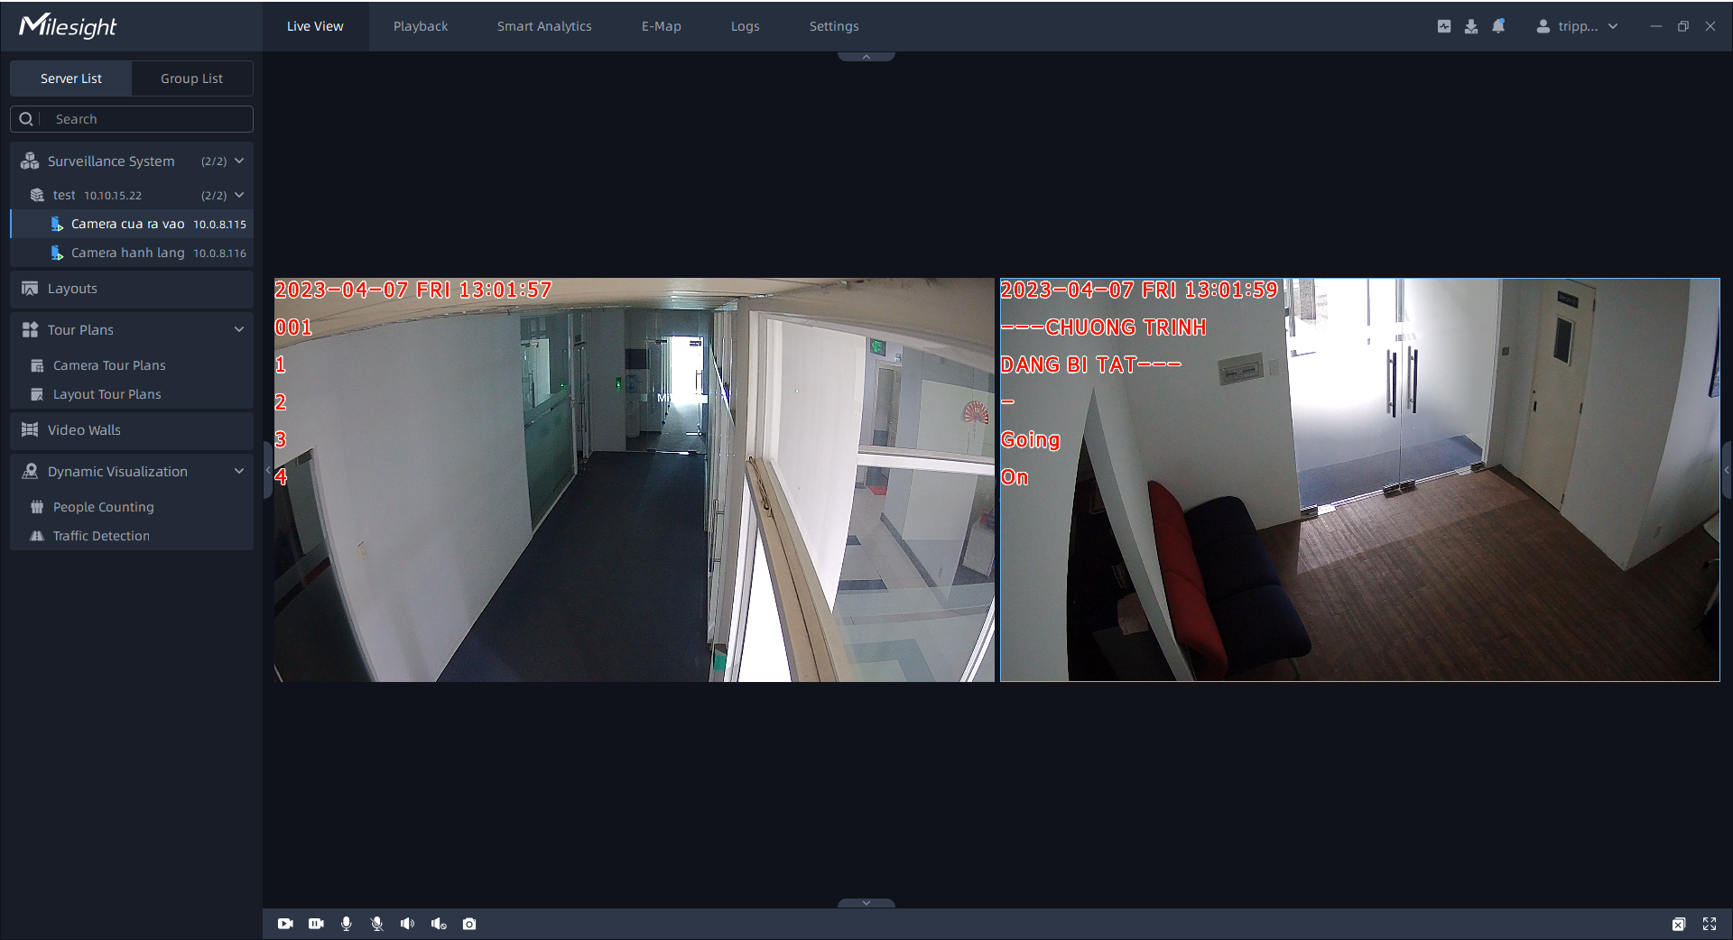

Figure 4. Camera view of Milesight VMS.

* **Features that need improvement:**

While the Milesight VMS app is a solid video management system, there are several areas where it could be improved for a better user experience:

- Simplify advanced features and settings to make them more accessible to all users.

- Improve app accessibility by providing alt text for images and icons.

- Resolves crashing and freezing issues reported by some users.

- Provide more detailed documentation and support resources to help users better understand and make better use of the app's features.

- Adjust costs for users, apply promotional campaigns for newcomers or long-term use packages to retain customers.

- Smartphone or mobile devices integration, which is not optimized

### VMS Axis

AXIS Camera Station is a comprehensive video management software designed for small and medium businesses, there are many similarities between Axis and Milesight. However, the integration feature of Axis is considered more convenient because it can allow users to integrate with their smartphones easier.

* **AI Integrated Features:**

**- Motion Detection (AI Integrated):** supports motion detection, can trigger recording and alert when motion is detected in the monitoring area.

**- Alarm Management (AI Integrated):** supports alarm management, allowing users to configure and manage alarms for different events, such as motion detection, fake camera impersonation and network problems.

**- License Plate Recognition (LPR)**: LPR technology can recognize and capture license plate information from vehicles. This is valuable for applications like parking management and security monitoring.

**- Behavioural Analytics:** AXIS VMS systems may include AI-based behavioural analytics. This allows for the detection of suspicious or unusual behaviours, such as loitering, object left behind, or crowd detection.

**- Audio Analytics:** AI can be used to analyse audio data, detecting specific sounds or anomalies, such as gunshots, breaking glass, or raised voices. This enhances situational awareness.

**- Object Tracking:** AI-powered tracking enables automatic tracking of moving objects within a camera's field of view. This can be useful for following individuals or vehicles as they move through an area.

**- Privacy Masking:** AI can be used to automatically blur or obscure sensitive information, such as faces and license plates, to address privacy concerns.

**- Integration with Access Control:** AXIS VMS systems can integrate with access control systems, allowing for seamless interaction between video surveillance and access control. This enables actions like automatically unlocking doors based on visual identification.

**- Customizable Rules and Policies:** AXIS VMS typically allows users to define custom rules and policies using AI triggers. These rules can automate responses to specific events, improving operational efficiency.

**- Data Analytics and Reporting:** AI can be used to analyse historical video data for patterns and trends. This data-driven approach aids in decision-making and optimizing security strategies.

**- Mobile App:** The Axis Camera Station mobile app allows users to access the surveillance system from their smartphone or tablet easily.

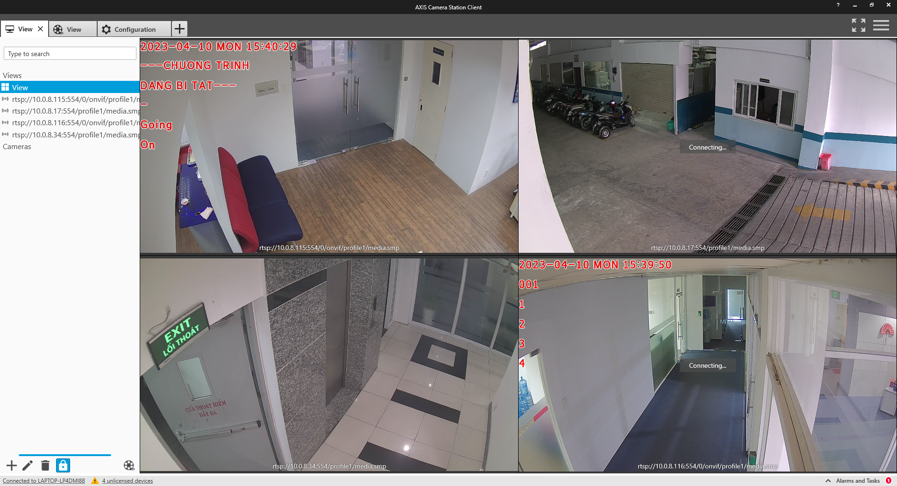

Figure 5. Streaming view of VMS Axis.

* **Integration Capability:**

**- Third-party device integration:** Axis Camera Station supports integration with third-party devices, such as access control systems, intercoms, and alarm systems motion. This integration enables a more comprehensive security solution that can be managed from a single interface.

**- API:** Axis Camera Station provides a wide range of APIs that allow integration with other software solutions. These APIs include goofAPI HTTP, VAPIX API, and ONVIF API.

**- Integrating Video Management Software (VMS):** Axis Camera Station can be integrated with other VMS solutions, such as Milestone, Kerberos.io, and Genetec. This integration enables a more comprehensive video surveillance solution.

**- Cloud integration:** Axis Camera Station can be integrated with cloud-based solutions, such as Microsoft Azure, Google Cloud Platform and Amazon Web Services (AWS). This integration allows remote access to a cloud-based video surveillance and storage system.

**- Video Analytics Integration:** Axis Camera Station supports integration with video analytics solutions, such as Axis Video Analytics and BriefCam. This integration enables the use of advanced video analytics and can provide more insight into video footage.

* **Features that need improvement:**

**- Resource-intensive live view:** Live view can be resource intensive, which may affect system performance. This problem can be solved by optimizing the live view feature to reduce its resource usage.

**- Storage Management:** Continuous writes can result in large amounts of data, which can be difficult to manage. Axis Camera Station can improve storage management to make it easier for users to manage their recorded footage. And if user would like to integrate the data on cloud service, be careful with the resource cost.

**- False alarms:** Motion detection can be prone to false alarms, which can be frustrating for users. Axis Camera Station can work to improve the accuracy of motion detection to reduce the frequency of false alarms.

**- Alarm Management:** Setting up and managing alarms can be time consuming. Axis Camera Station need to improve its alarm management capabilities to make the alarm setup and management process more efficient.

**- Mobile app functionality:** Mobile apps may not provide the same level of functionality as the desktop version. Axis Camera Station can work to improve the functionality of mobile applications to provide users with a more comprehensive remote access experience.

## Conclusion

Generally, together we have had an overview of several software testing concepts as well as learned what outstanding features current AI-integrated video management system software have through the research of Axis and MileSight VMS.

With the information we have, in the next two chapters, this thesis hopes to bring the stated theories and apply them into practice.

How is an AI vision system trained? How is a camera management system built?

What is the practical way to go about testing an AI system at a business?

As a tester, what we need to understand our end users need?

Answering the above questions together through simulating an intrusion warning project, conducting some testing for an AI-integrated video management system at ITD company, and write a sample of script test will give an AI test engineer a more realistic view in this industry.

Last but not least, this thesis brings along the great purpose of helping readers gain the most basic knowledge before stepping into the position as a test engineer.

# simulation of an AI cameara application

Gaining insight into the workflows of both the AI and IT teams is critical as an AI system test engineer. This chapter seeks to provide a thorough overview of the tools and procedures used to accelerate AI model training. In addition, we will investigate the creation of a basic smart alarm system – Intrusion Warning. This investigation will not only aid in a deeper understanding but will also be useful while working on smart camera system projects. Let's take the first step in any workflow in the AI industry today, **“Implementing a pilot project to gain momentum”**.

## Simulation project of an AI training model.

Preparation: Google Drive, Google Collab, training dataset image, training dataset label.

The reason for using the Google Drive and Google Collab toolkit to train an AI model is because these two software execute commands on cloud platforms, ensuring local machine resources are guaranteed to execute some additional tasks. Furthermore, Google Collab’s runtime will be refreshed after a specific time. The question needs to be solved here is: “While the system training a big dataset, is it okay to perform almost tasks like uploading dataset from local machine, setting up, installing, … training model?”

Fortunately, the solution come with Google Drive, where is the best place that we can store dataset folders, training files, .yaml file, … Help us to communicate data, organize files effectively for the training process and performance. Let’s create and set up a drive folder like [this](https://drive.google.com/drive/folders/1aUHAatJntGiw8ntURGBxJGkLB8wkV2ut?usp=sharing):

* To begin the process of “eating the cake up size down”. Firstly, focusing on the data folder, the image below would describe the standard file structure for using in training data for a computer vision AI model purpose.

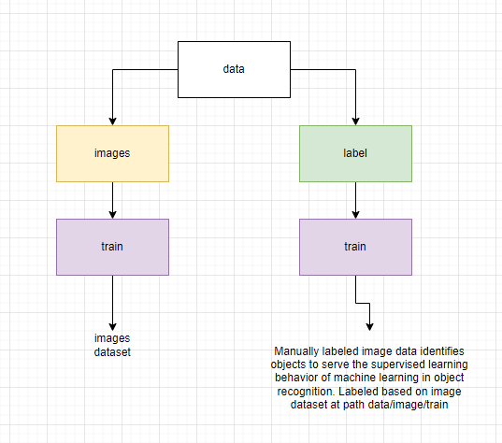

Figure 6. file structure for using in training data.

* How can we label the image dataset for supervised learning? There are too many ways or tools these days for implementing those tasks (from opensource, company’s library, company’s software) but let’s explore this process in the fastest and easiest way through an UI Web-based platform through <https://app.cvat.ai/>.

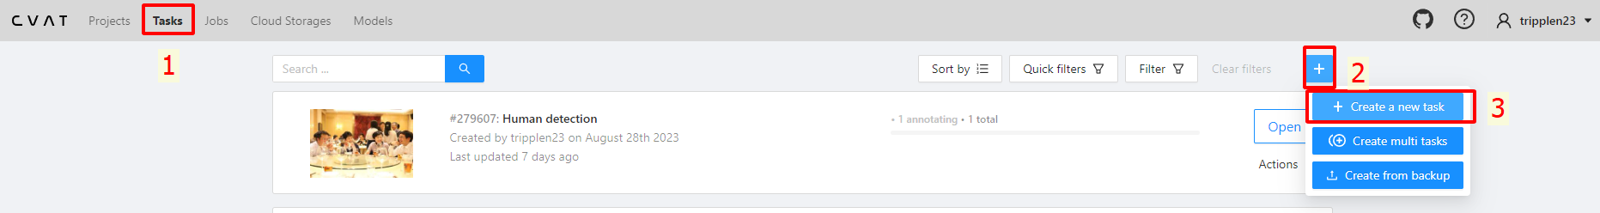

Figure 7. Labelling the image dataset for supervised learning.

* After registering and signing in, Click the “Task” (1) on the web navbar and then modify on the “+” button (2) and then “Create a new task” button (3) for creating a new task in order to label from an uploaded dataset.

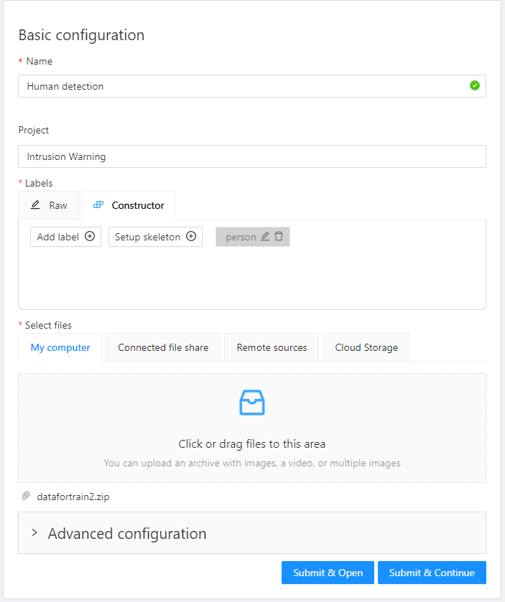

Figure 8. Configuration for labelling task.

* Modify the task, then click on the button “Submit & Continue”. For dataset, we can collect from our own image data, and it is also able to download from several Internet resources such as [CrowdHuman Dataset](https://www.crowdhuman.org/).

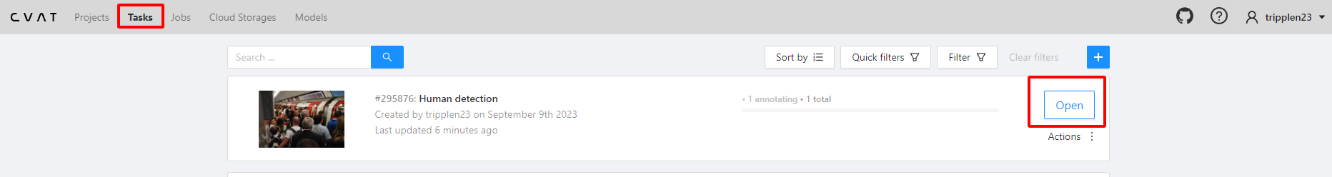

Figure 9. Opening the task project for labelling.

* Go back to the “Tasks” and click on “open” button on the top task (the newest task), then implement the task like the following image:

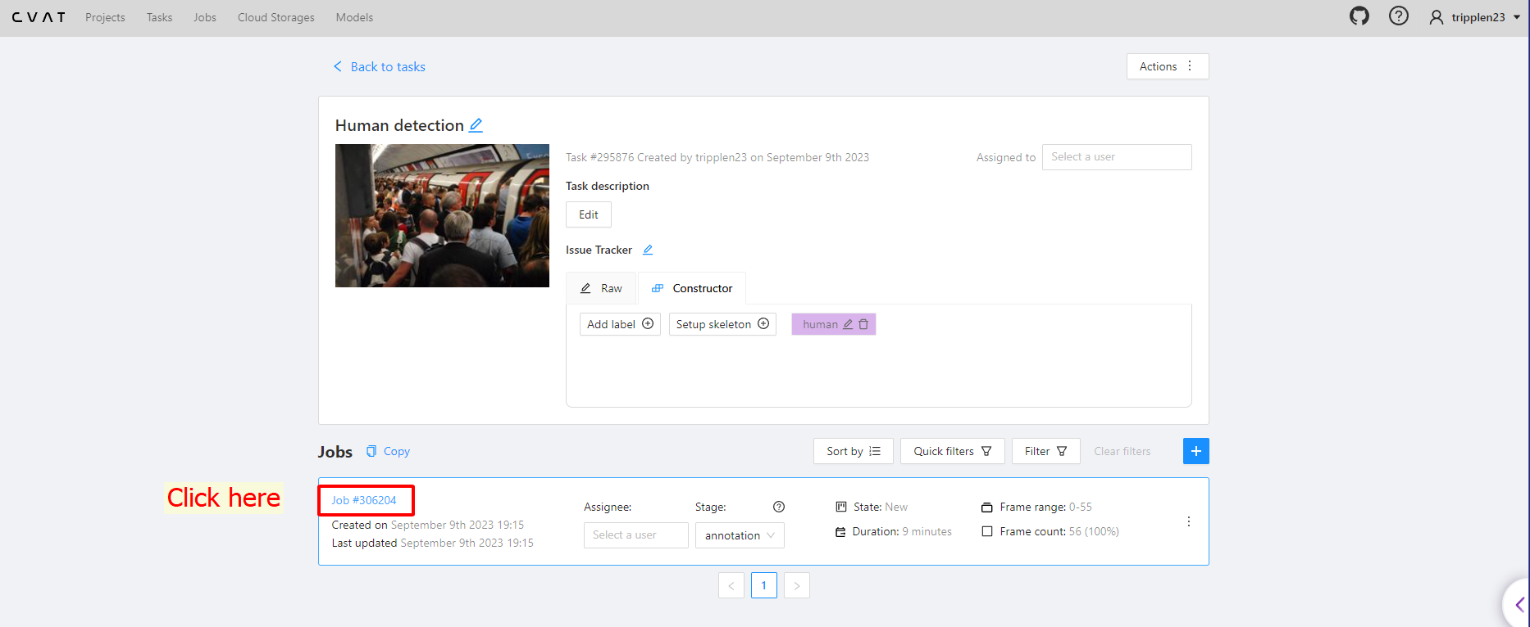

Figure 10. Going to the job#[id] for labelling.

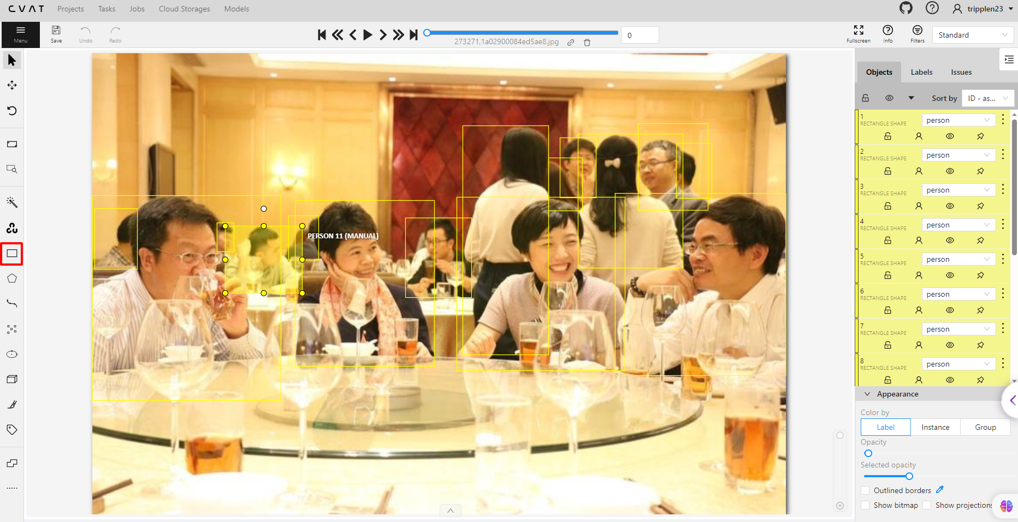

Figure 11. Labelling the objects manually.

* Click on “Draw new rectangle” button or “Draw new polygon” button or any other options we want, then press the keyboard short “n” for new drawing. We can do this process as much as possible as the more dataset, the more in accuracy for machine to detect our object. Remember to click on the “Save” button after drawing or press the “Ctrl + S” legendary keyboard shortcut.

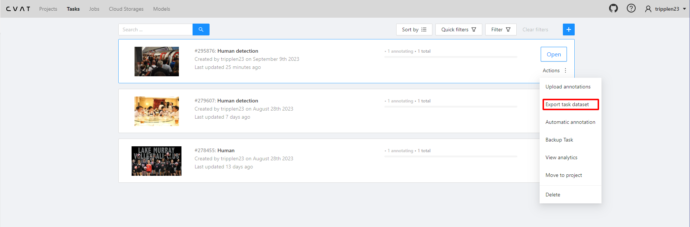

Figure 12. Exporting labelled dataset.

* After labelling all our dataset, go back to the “tasks” path, hover mouse to “Action” element, then click the section on “Export task dataset”, remember to modify the export format into YOLO1.1 as we will use the source code of YOLO (You Only Look Once) for training our AI model.

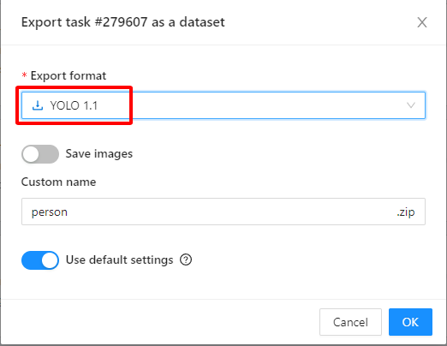

Figure 13. Modifying the export format into YOLO1.1.

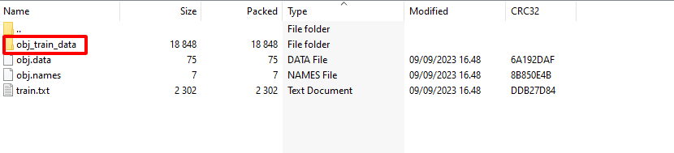

Figure 14. obj_train_data in the person.zip that we exported.

* After exporting, go into the “person.zip” file that we downloaded, there is the folder inside named “obj_train_data”, this folder contains every needed labeled image data for training and for us to place into the path we set up before at **My Drive/ComputerVision/TrainYoloV8/data/labels/train.**

path: "/content/gdrive/My Drive/ComputerVision/TrainYoloV8/data" *# dataset root directory*

train: images/train *# train images (relative to 'path')*

val: images/train *# val images (relative to 'path')*

*# Classes*

names:

  0: human *# or person, it’s up to us*e

* Create a google_colab_file.yaml in order to get access into the dataset with the defined classes.

from google.colab import drive

drive.mount('/content/gdrive')

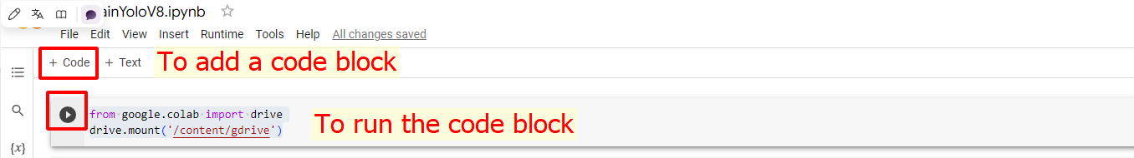

Figure 15. Start the Google Collab and connect to Google Drive.

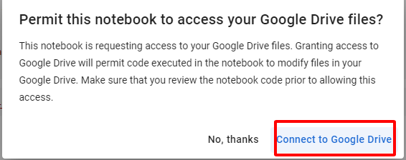

Figure 16. Connecting Google Drive after running the above code.

* Now, let’s modify several code in our Python Notebook Google Collab .ipynb, the first 2 lines are import class ‘drive’ in the google.colab library and then we use it for mounting our Python project to that drive.
* After signing in successfully on the Drive with the same account we used, the output in the terminal would be:

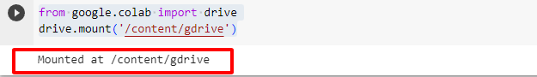

Figure 17. Mounting to Google Drive successfully.

* On the next line, we will initialize a variable “ROOT_DIR” which indicate the root directory on our Google Drive project:

ROOT_DIR='/content/gdrive/My Drive/ComputerVision/TrainYoloV8'

* After running the above code, let’s install the ultralytics library. Ultralytics library is a high-level deep learning library and toolkit that simplifies and enhances the process of training and evaluating AI models, particularly for computer vision tasks. It’s designed to work with popular deep learning frameworks like PyTorch and provide streamlined interface for training, evaluating, and deploying computer vision models.

!pip install ultralytics

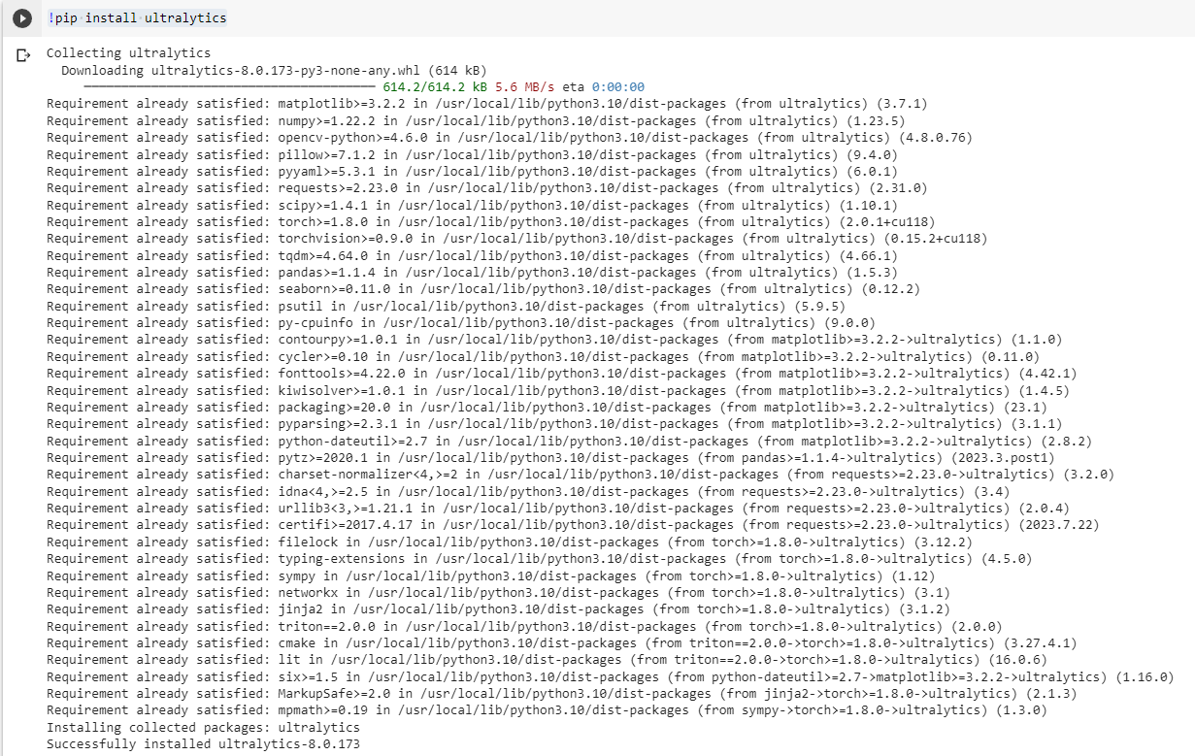

Figure 18. Installing ultralytics library in Google Collab Python notebook.

* Then the following code block will be a modified code of a training YOLOv8 model, reference by [this resource.](https://github.com/ultralytics/ultralytics)

import os

from ultralytics import YOLO

# Load a model

model = YOLO("yolov8n.pt")  # load a pretrained model (recommended for training)

# Use the model

results = model.train(data=os.path.join(ROOT_DIR, "google_colab_file.yaml"), epochs=1) # Train model

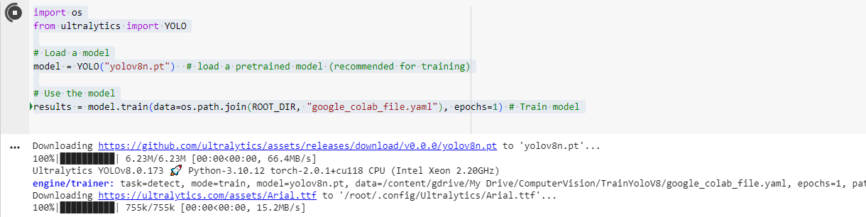

Figure 19. Importing os module to interact with the operating system.

Code overview:

1. **`import os`:** Imports the Python `os` module, which provides a way to interact with the operating system, including file and directory operations.

2. **`from ultralytics import YOLO`**: Imports the YOLO class from the Ultralytics library, specifically for YOLO-based object detection tasks.

3. **`model = YOLO("yolov8n.pt")`**: Creates an instance of the YOLO model by initializing it with a pre-trained model checkpoint named "yolov8n.pt." This pre-trained model serves as a starting point for further training on a custom dataset.

4.**`results=model.train(data=os.path.join(ROOT_DIR**, **"google_colab_file.yaml"), epochs=1)**`: Initiates the training of the YOLO model. Here's what's happening in this line:

- `**data=os.path.join(ROOT_DIR, "google_colab_file.yaml")**`: Specifies the path to a YAML config file("google_colab_file.yaml") that defines the dataset and training settings. `ROOT_DIR` is assumed to be a variable or constant containing the root directory path.

- `**epochs=1**`: Sets the number of training epochs to 1. An epoch is one complete pass through the entire training dataset.

- `**model.train(...)**`: Initiates the training process using the specified configuration file and settings. During training, the model will optimize its parameters based on the provided dataset and training parameters.

- `**results**`: Receives the training results, which can include metrics, losses, and other information about the training process.

Overall, this code loads a pre-trained YOLO model, specifies a custom dataset and training settings through a YAML configuration file, and then starts the training process for one epoch. We can modify the number of epochs and other training parameters according to our specific requirements.

* After training the successfully (It may take a time), let’s export our model file and use our trained model with our purpose in the following line:

!scp -r /content/runs '/content/gdrive/My Drive/ComputerVision/TrainYoloV8'

For more detail of how our Google Python notebook look like, see [here](https://drive.google.com/file/d/1RUBh7fbZ0yPJJiMibDm7cvVnwKquvnhq/view?usp=sharing) and open it in Google Collab.

We have now several clarities in a question of how to make a pilot project for training an AI model. The next question is how to make an AI camera system pilot project. The following part of this chapter will go into more detail with the answer. In the next one, we will use a pre-trained model YOLO v3 and have a deep view in how everything is work.

## Intrusion Warning Project (With YOLO & OpenCV)

### What is Intrusion Warning?

Intrusion Warning in the scope of this thesis is a small AI Camera System, which firstly detect an object, specific here is “person” object class by a pre-trained model YOLOv3. Besides, the system allows us to draw a polygon area for allocating the restricted area via our monitored camera, and then update the warning status whenever the centroid of the object detected is inside the drawn polygon area.

Furthermore, we will take a look in using a telegram bot API with our app that will notify us whenever the system detects a person is inside our restricted area.

The application is not only applicable in the security industry but also in the marketing strategy, which identify the habit of choosing product of customer, and more and more field of business in our World.

The image below describes clearly about the workflow of our intrusion warning project.

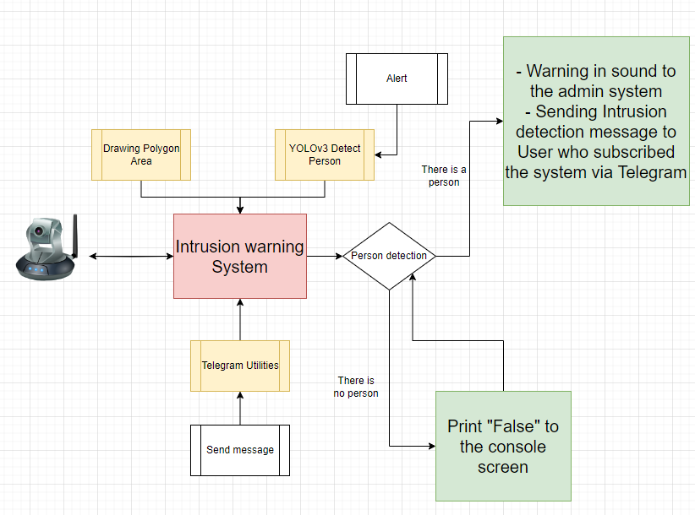

Figure 20. Workflow of Intrusion Warning project.

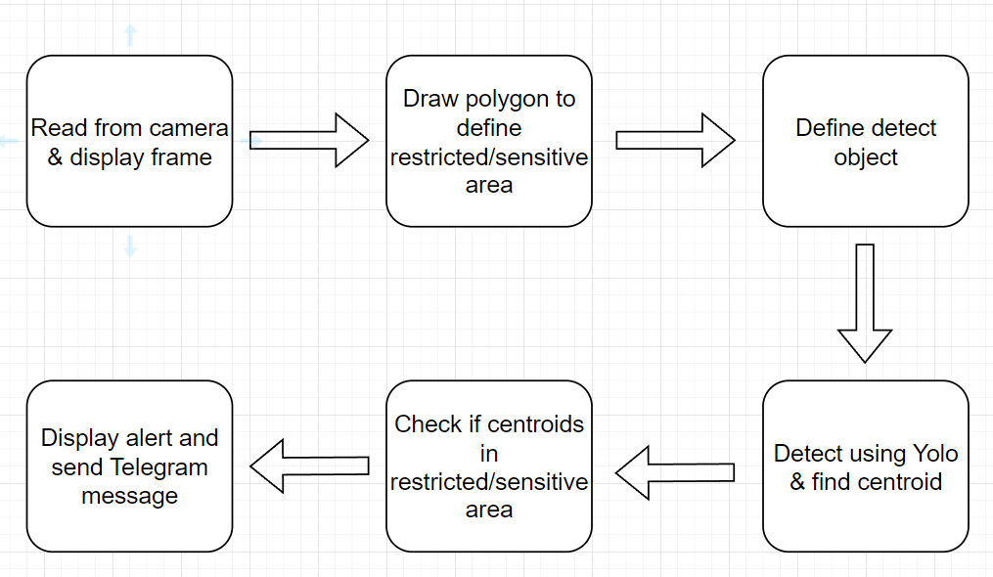

Figure 21. Pipeline of the Intrusion Warning project.

Pipeline description:

* Firstly, make sure that we create a Camera System that can connect a real camera. Let’s take our webcam for the easiest way for this situation.
* Ensuring that our main system integrates all the different factors includes drawing a sensitive polygon.
* The system will calculate the centroid point of the object (in this case, a person) and considering whether that centroid point is located in the restricted area - the previously drawn sensitive area.
* If the object's centroid point is in a zoned sensitive area, return a notification on the screen, send a message via telegram bot.
  + If not, continue detecting until the intruder is detected.



Figure 22. Centroid of human example.

“The centroid” is a geometric property of an object that represents its center of mass or balance point. For shape like a human body, the centroid point is the average position of all the individual points that make up the object. And in deeper way how we calculate and analyze the centroid point algorithm, move to the next sub-part. The practical time.

### Building Intrusion Warning System application:

Source code: [thesis/Intrusion warning at main · tripplen23/thesis (github.com)](https://github.com/tripplen23/thesis/tree/main/Intrusion%20warning)

Get the pretrained model [here](https://drive.google.com/drive/folders/19Dx4WInLRKh5TnUkdTucFQ8gi0yB4D4a?usp=sharing).

Requirement:

* Python >=3.8.
* [Installing Miniconda — miniconda documentation](https://docs.conda.io/projects/miniconda/en/latest/miniconda-install.html) – For creating a Python Virtual Environment on local machine.
* OpenCV – For drawing, implement several tasks like detection, end task, … on our camera, webcam, video screen.
* Aiogram version 2.15 – Library that handle the sending message task though a Telegram bot.
* Shapely library: Allow us to work with various geometric shapes such as points, lines, polygons. In this scope of the project, we will use it for checking if a Point is inside or outside a Polygon.

Let’s get started, Firstly, create an empty folder named “Intrusion Warning” right click on that folder -> Open with Visual Studio Code -> Open new Terminal -> Enter command line “conda activate myenv” for activating our virtual environment



Figure 23. Activating conda virtual environment.

Next, create now a setup.txt file, which indicate required external libraries for our project, the setup.txt have the following content:

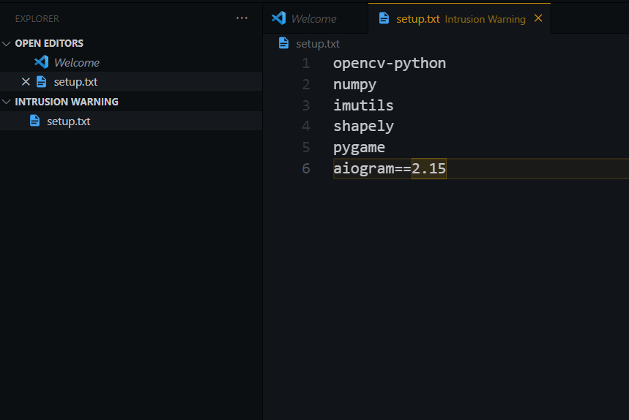

Figure 24. Required external libraries for our project.

Then, type command line **“pip install -r setup.txt”** for installing all the required libraries.

After that, make sure our application can connect to the real camera, we will take our webcam for implementing this purpose via the “main.py” file.

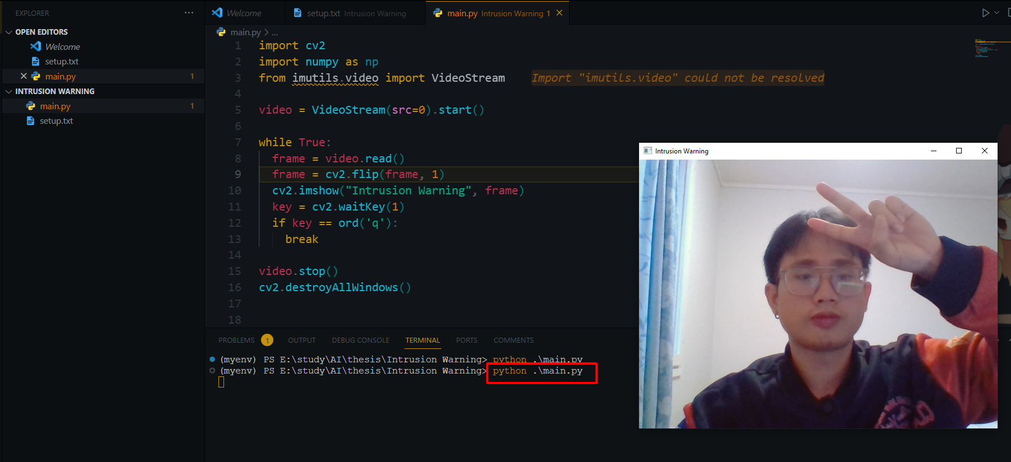

Figure 25. Use project to turn on webcam.

Code Overview:

* Import necessary libraries (Line 1-3).
* Start a video stream from the default camera (src = 0) (Line 5).
* Enter a loop to continuously capture and display video frames **“while True”** (Line 7-13).
  + Flip each frame horizontally (mirror effect) using **“cv2.flip”** (Line 9).
  + Display the flipped frame in a window titled “Intrusion Warning” using **“cv2.imshow”** (Line 10).
  + Continuously check for user input using **“cv2.waitkey(1)”** (Line 11).
  + If the **“q”** key is pressed, exit the loop (Line 12-13).
* Stop the video stream using **“video.stop()”** (Line 15).
* Close all OpenCV windows with **“cv2.destroyAllWindows()”** (Line 16).

The next step, download the pre-trained model from [AlexeyAB/darknet: YOLOv4 / Scaled-YOLOv4 / YOLO - Neural Networks for Object Detection (Windows and Linux version of Darknet ) (github.com)](https://github.com/AlexeyAB/darknet). However, this thesis prepare for us a minimal custom folder to download YOLOv3 [here](https://drive.google.com/drive/folders/1vs-dJ8gL2Gdu4Ns-OaQeiOnF1PzE_oCr?usp=sharing). Our project will look like below in our structure:

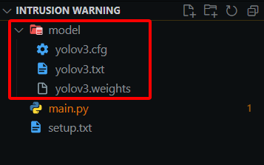

Figure 26. Pre-trained model folder.

Now, create a new file **“yolodetect.py”**, copy whole content in [here](https://github.com/tripplen23/thesis/blob/main/Intrusion%20warning/yolodetect.py) and paste to our new file.

The provided Python code is part of a program designed for real-time object detection, specifically for detecting humans using the YOLO (You Only Look Once) model. It integrates various functionalities, including object detection, drawing bounding boxes, calculating centroids, and triggering alerts. Here's a concise analysis of our code

* Imports necessary libraries and initializes audio playback:
  + OpenCV (cv2): Used for image and video processing.
  + NumPy (numpy): Used for numerical operations.
  + Shapely (shapely.geometry): Used for geometric operations, such as checking if a point is inside a polygon.
  + telegram_utils: Custom module for sending alerts to Telegram.
  + pygame.mixer: Used for playing an audio alert. (Take the file audio/alarm2.wav [here](https://github.com/tripplen23/thesis/tree/main/Intrusion%20warning/alarm_audio)).

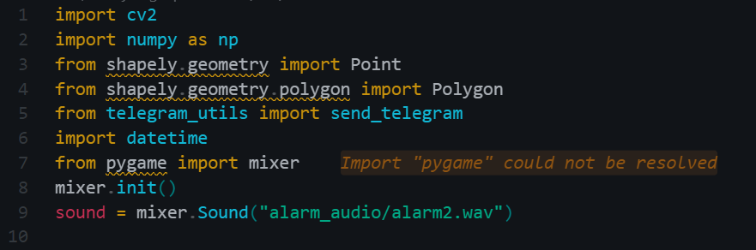

Figure 27. Importing libraries for file **“yolodetect.py”.**

* Defines a function **”isInside(points, centroid)”** to check if the centroid of detected person is inside a specified polygon area using Shapely geometry.

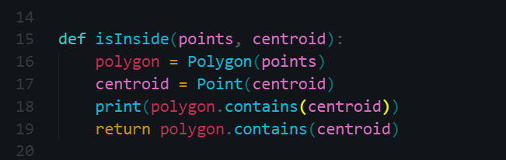

Figure 28. Define **“isInside”** function.

* Defines a class **“YoloDetect”** class for object detection:
  + Initializes parameters, such as YOLO model files, confidence thresholds, and frame dimensions.
    - Modify the sending telegram alert in each 15 second whenever an object is detected in the restricted area. This helps us avoid sending notification messages continuously, causing negative impacts on server resources as well as the inconvenience to users who register for the service.

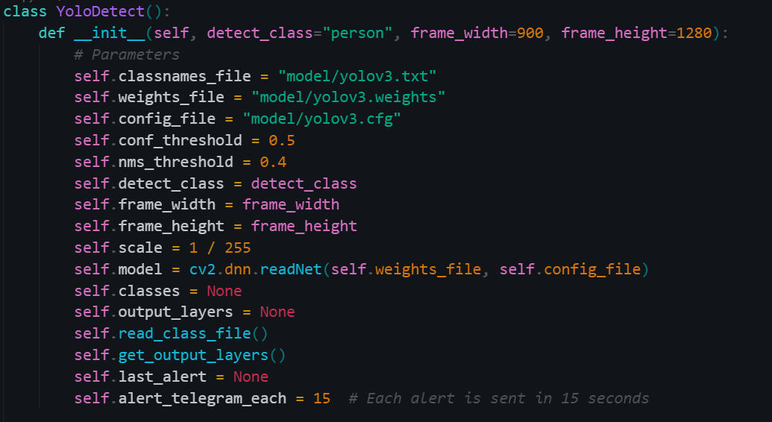

Figure 29. Defines a class **“YoloDetect”** class for object detection.

* Reads class names from a file.

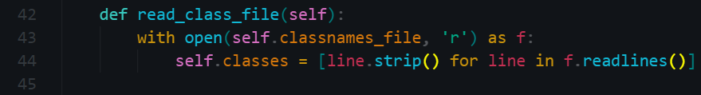

Figure 30. Define **“read_class_file”** function in the **“YoloDetect”** class.

* Sets up the YOLO model and output layers.

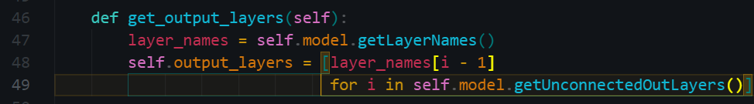

Figure 31. Define **“get_output_layers”** function in the **“YoloDetect”** class.

The code blocks provided above serve as the foundational configuration of the YOLO model within our project. The subsequent functions contained within the **`YoloDetect`** class will play a crucial role in implementing the core functionality of this class. Consequently, let's take a closer look at these functions to gain a deeper understanding of their role and significance within the class.

The **`draw_prediction`** function inside the `YoloDetect` class is responsible for drawing predictions on a given frame based on the results of object detection. It specifically draws bounding boxes around detected objects, labels them, calculates the centroid of each bounding box, and performs additional actions when a centroid is inside a specified polygon area.



Figure 32. Define **“draw_prediction”** function in the **“YoloDetect”** class.

Here's a detailed analysis of the code and algorithm within the **`draw_prediction`** function:

Parameters:

* **`img`:** The input image frame where predictions will be drawn.
* **`class_id`:** The class ID of the detected object "person").
* **`x`, `y`:** The coordinates of the top-left corner of the bounding box.
* **`x_plus_w`, `y_plus_h`:** The coordinates of the bottom-right corner of the bounding box.
* **`points`:** A list of points defining a polygon area.

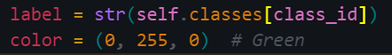

Figure 33. Declaring variables **"label**" and **"color"** inside the **“draw_prediction”** function.

* **`label`:** Retrieves the class name based on the **`class_id`**.
* **`color`**: Defines the color for drawing the bounding box (in this case, green).

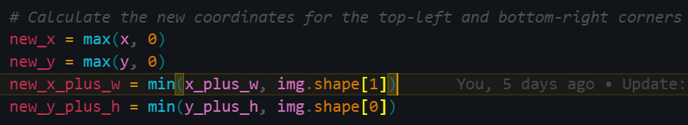

Figure 34 Declaring variables for Calculating the coordinates inside the **“draw_prediction”** function.

* The code ensures that the bounding box coordinates (`new_x`, `new_y`, `new_x_plus_w`, `new_y_plus_h`) do not extend beyond the image boundaries to avoid errors when drawing.

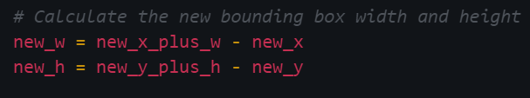

Figure 35. Declaring variables for Calculating the bounding box inside the **“draw_prediction”** function.

* **`new_w`** and **`new_h`** represent the width and height of the adjusted bounding box.

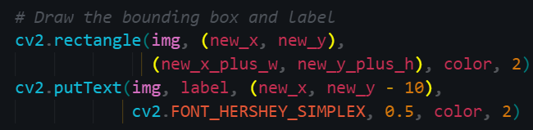

Figure 36. Drawing the bounding box inside the **“draw_prediction”** function.

* The code uses OpenCV functions to draw the bounding box and label on the image.

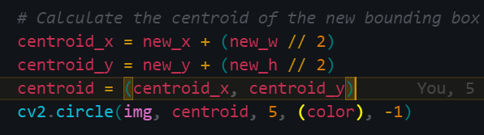

Figure 37. Calculating the centroid point.

* The centroid of the adjusted bounding box is calculated as the midpoint of its width and height.
* A small green circle is drawn at the centroid position on the image.

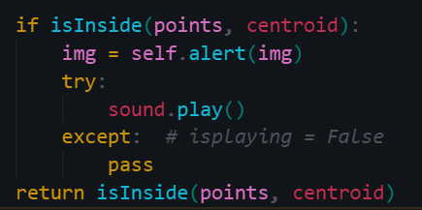

Figure 38. Conditional statement for sound alerting.

* The **`isInside`** function is called to check if the centroid of the bounding box is inside a specified polygon area (`points`).
* If the centroid is inside the polygon, an alert is triggered, and a sound is played.
* The function returns a Boolean indicating whether the centroid is inside the polygon.

Finally, the 2 methods left in the Class YOLO detect is simply take the responsible for

Triggering an alert from **“alert”** method:

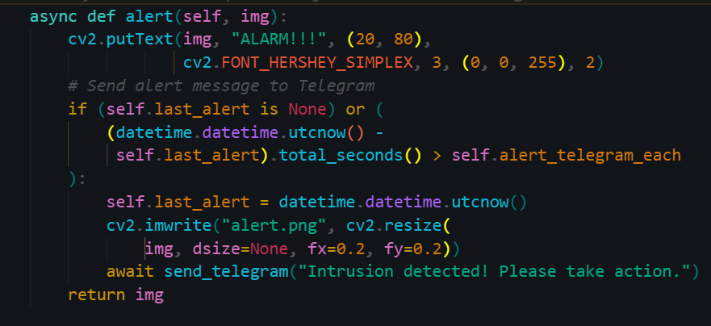

Figure 39. Define **“alert”** function in the **“YoloDetect”** class.

The **“detect”** method processes video frames

* Converts frames to suitable format for YOLO
* Runs object detection using YOLO and filters results based on confidence and class.
* Draws bounding boxes and centroids for detected humans.
* Triggers an alert when a human is detected inside the polygon.

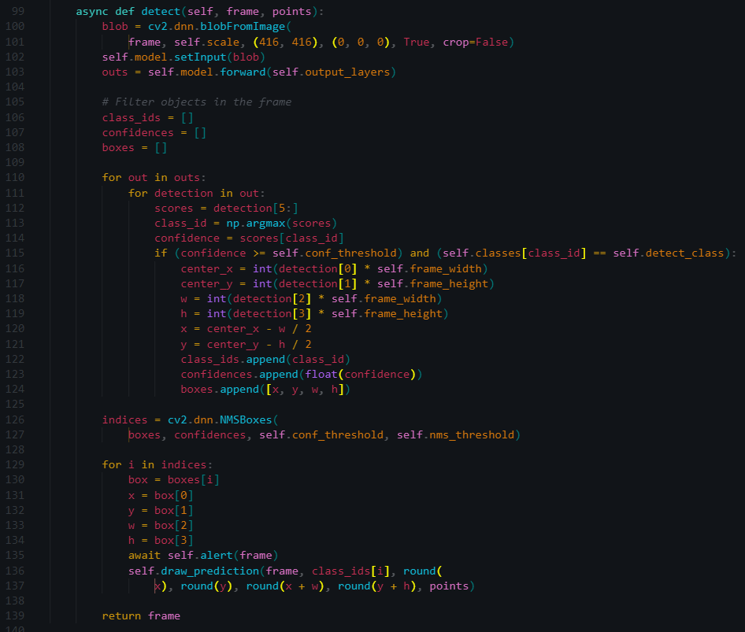

Figure 40. Define “detect” function in the “YoloDetect” class.

Read the [instruction](https://github.com/tripplen23/thesis/blob/main/Intrusion%20warning/telegram_bot_instruction.md#2-create-a-telegram-bot-with-botfather-verified) of using telegram bot via Python app in version controller link:

After creating a Telegram bot, get Bot ID and User ID, let’s create a file **“telegram_utils.py”** with following content (remember to use bot token/chat_id that we have collected ourselves):

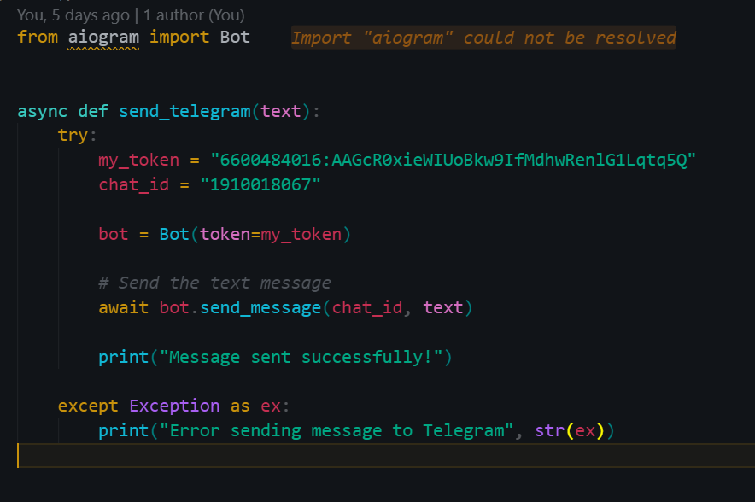

Figure 41. Modifying the **"telegram_utils.py"** file

Lastly, let’s modify our **“main.py”** file, take the source code [here](https://github.com/tripplen23/thesis/blob/main/Intrusion%20warning/main.py) and enjoy our achievement by:

+ Draw a polygon for restricted area by click to choose the point on the video displayed.

+ Press keyboard shortcut “d” for detecting after choosing points of Polygon. Our algorithm also helps us to make a connection between the last chosen point and the first one we choose.

+ Press keyboard shortcut “q” for end all video process.

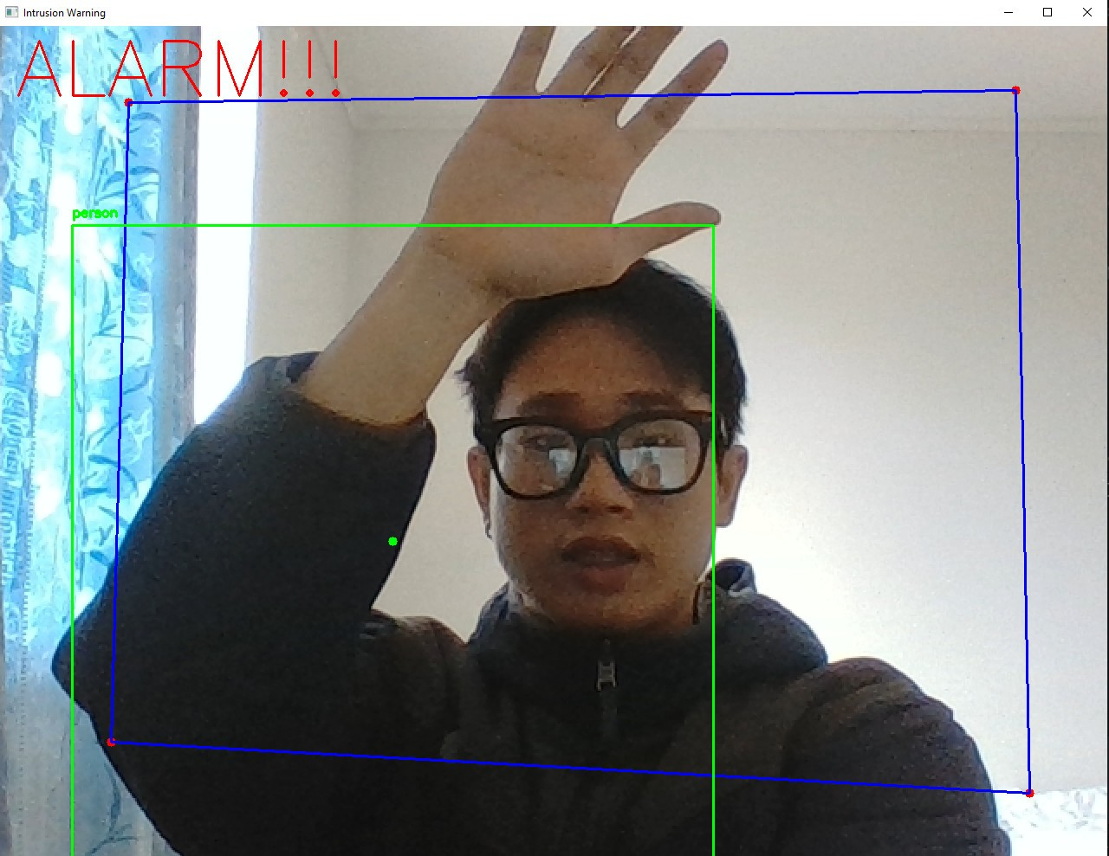

Figure 42. Detected person inside the restricted area successfully.

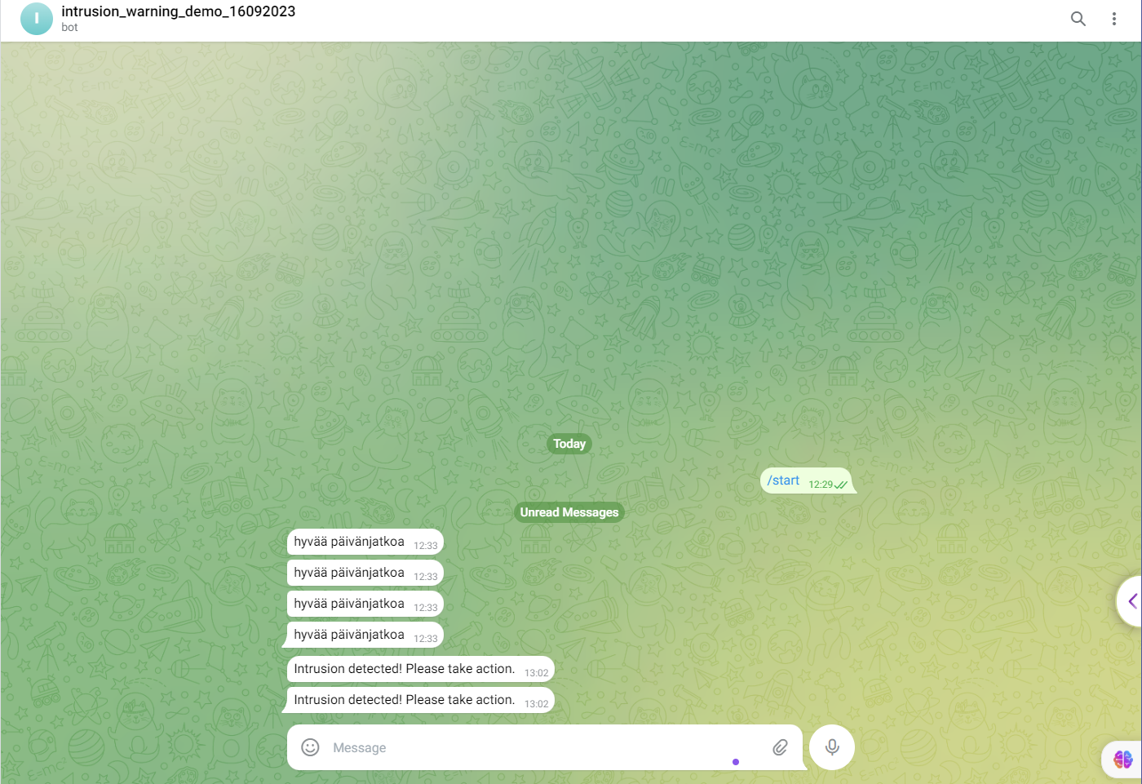

Figure 43. Our Intrusion Warning system sends telegram warning message successfully.

## Our Mission

Through a demo of the identification/warning video system and an overview of the process of training an AI model. Together we have a broader view in this field. However, for an AI product to gain a strong foothold in today's competitive market, continuous updating, optimization, and research are stories that deserve attention.

When a human being is born and grows up, from infancy to adulthood, he always needs mistakes and stumbles to become more and more mature. Besides, the logistics and support of parents and teachers around are also very important on this path.

And the same goes for a machine, we are the ones who are gradually creating them. In terms of social relationships, humans are now like the parents of artificial intelligence. We need to correct, teach, and supervise these children conscientiously, ready to point out the errors that this brainchild is making, so that the child can make better and better progress.

In the next chapter, we will play the role of supervisors and be ready to point out errors that the system is experiencing in an extremely serious way. An AI Testing Engineer is a metaphor for teachers in the age of robotization.

We will teach together at a school called ITD where AI Camera System is used for many different purposes, and to understand these children better, we need to know the rules of their activities and let’s read the rules together. [here:](https://github.com/tripplen23/thesis/blob/main/thesis_report/APIDescriptionDocument.docx)

# Testing Stategies (In practice)

After carefully reading the documents describing an AI or API in any business or project (Here we have referenced ITD company as an example), an AI testing engineer in the company needs to have the following: Take a broader look at some of the processes in the process of providing tests for the system or the "intelligence" of the artificial intelligence that your organization owns.

Furthermore, as a tester, our mindset needs to become more independent from the software construction and development team, which means that we and the end users will be the one side and will not hesitate to point out defects that the general system or software is experiencing.

Test engineers will play a very important part in the stage of before publishing the final product, ensuring that the software will be carefully packaged to help increase competitiveness and customer satisfaction once the product is available on the marketplace.

In this chapter, we will have a preliminary look at testing a project for the purpose of “Support improving the recognition features” from using tools like Postman, several useful tips when using Postman and basic algorithms of writing Unit Tests. At the same time, this thesis will dig deeper into writing a script test for the “Object Tracing” feature to help organization having a better point of view to improve this module.

## Manual Testing with Postman and Unit Testing with Pytest:

Because of some compromises with the ITD company to not expose too much of the company's data resources to the outside. The content of this thesis will therefore only give us an overview of how to apply what we read in an AI API description documentation.

### Manual testing with postman:

This is the easiest way to approach testing backend APIs that our IT team has written. See if the response sent back from the system is in accordance with what our team previously programmed and recorded on the [API description document](https://github.com/tripplen23/thesis/blob/main/thesis_report/APIDescriptionDocument.docx).

* Encode the image into Base64 format by a webapp [here](https://www.base64-image.de/):

Step 1: Register a face to the AI recognition system

* API URL of ITD: 8004/face_registration
* [Image used](https://drive.google.com/file/d/10Qv3TGcrAxSsQTzXAASYQZSbr3j9z6V5/view?usp=drive_link)
* [Response Data](https://www.notion.so/image/https%3A%2F%2Fs3-us-west-2.amazonaws.com%2Fsecure.notion-static.com%2F50754711-74d5-4b4f-8308-bb35bfc5619d%2F2.png?table=block&id=19e679fb-0368-4a7d-81ff-db21145f190d&spaceId=2ee80eb6-7237-44d9-b9ed-be4959866b3b&width=2000&userId=8111ef9f-03d9-46db-a6bb-c48ce8127521&cache=v2)

We use here the JSON format that the document has mentioned as:

|  |
| --- |
| {  "TimeSend": "2023-01-06T09:10:49,182",  "Item": {  "ImageData": "[Base64Image]",  "FaceID": -1,  "OpCode": 0  } |

Response Data notify us meaning that the result was as expected, successfully registering the face with a full-body photo.

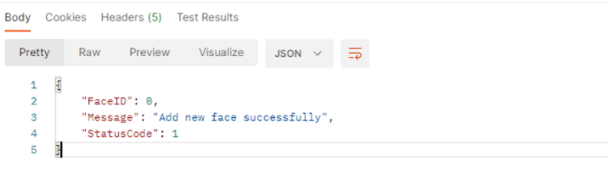

Figure 44. Register a face to ITD's database successfully.

Step 2: Check if the system correctly verifies the registered person in case that person changed his clothing.

* API URL of ITD: 8004/face_verification
* [Image used 1](https://drive.google.com/file/d/1FaxN__shUAAr3UbvUVC1QcBpvHGP4PGm/view?usp=drive_link)
* [Image used 2](https://drive.google.com/file/d/1UsPba-n7vErpNLMeyPHoT0DrvH7pf17j/view?usp=drive_link)
* [Response Data 1](https://www.notion.so/AI-h-tr-n-ng-cao-t-nh-n-ng-nh-n-di-n-227d0d99077143a79ef59b59748e5308?pvs=4#60314d44dac24f8eb7b34272b4277960)
* [Response Data 2](https://www.notion.so/AI-h-tr-n-ng-cao-t-nh-n-ng-nh-n-di-n-227d0d99077143a79ef59b59748e5308?pvs=4#9fa40cbc21f74aca8bf97ea0b1119a5f)

We use here the JSON format that the [document](https://github.com/tripplen23/thesis/blob/main/thesis_report/APIDescriptionDocument.docx) has mentioned as:

|  |
| --- |
| {  "TimeSend": "2023-01-06T09:10:49,182",  "Item": {  "ImageData": "A91h3jyjksi1",  "FaceID": 0,  }  } |

The results were as expected, successfully confirming the same rate as the registered face at 74% and 69% respectively.

About our thinking way, as a tester, we should set our own curiosity at another level (unlimited), we should not only test the successful cases, but also need to put our heart into testing error cases such as adjusting the wrong time format, adjusting the JSON format to text, wrong image format. photo, wrong FaceID, ...

The above mindset will lead us to encounter more error responses from the system, and sometimes those errors are not catch exactly by the software backend system which IT department had programmed before.

Our mission after retrieving those responses is to report them to the software development team to optimize the work of catching more different errors within the organization's software system.

Looking at some examples of the above information may seem quite vague to several newcomers. Therefore, in the following pages our thesis will focus on some setting up tips to make manual testing workflow become faster and more convenient every time we step into a similar project.

Follow the following below set up steps to have a better experience for your next Postman testing:

1. First and foremost, to keep our workspace to be clean and reusability we need to set a proper name for our workspace. For example:

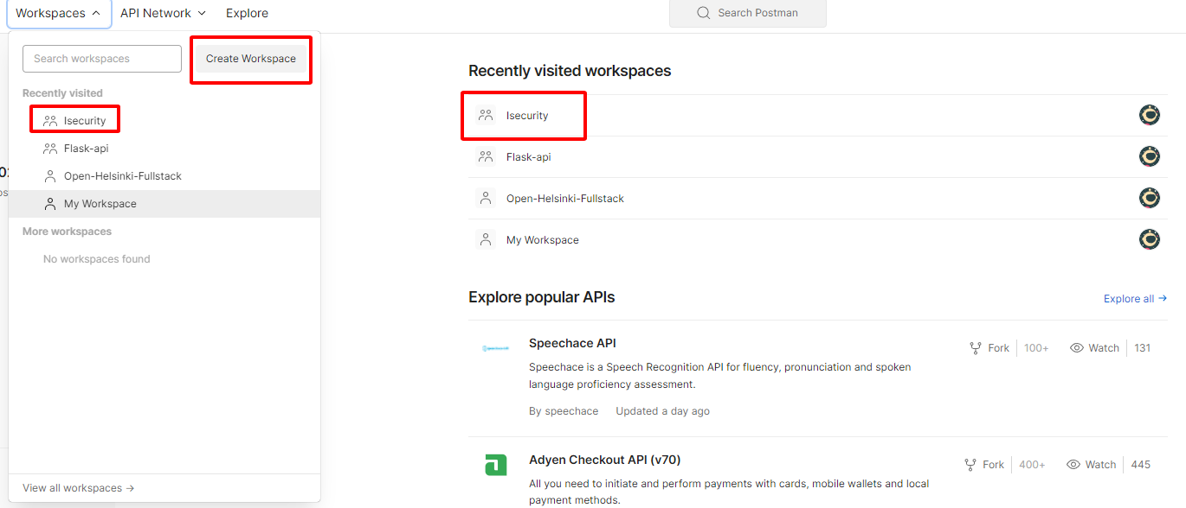

Figure 45. Create a Workspace for our project, here I created one named Isecurity.

1. Based on the information about the API that we had read through the AI API description documentation, our task now is to allocate each API into separate collections. For example:

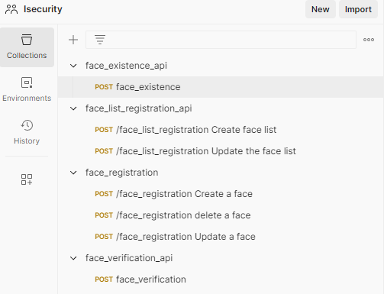

Figure 46. Allocating each API into separate collections with Postman.

1. Setting up the url Environment, this job helps us to use the shortcut url, make a more convenient way in connect with our organization’s API address. Step by step to do as the following instruction like the picture below: (1) Access to Environments; (2) Choose environment we will use, if there is no environment yet, create one by clicking on the `+` button; (3) Configure our working environment; (4) Choose the working environment.

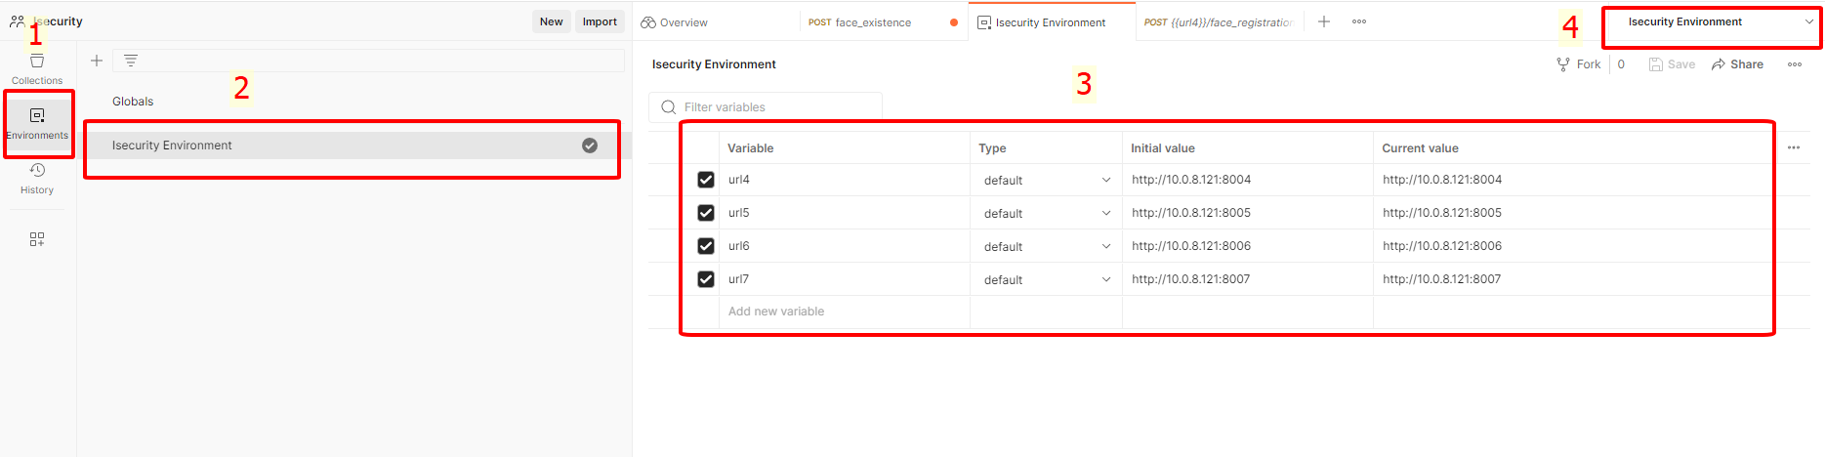

Figure 47. Setting up the url environment with Postman.



Figure 48. Shortcut for url address we use after setting up url environment for example **{{name_of_url}}**.

1. Do not forget to configure our request message into the proper format. Here we use JSON format as the AI description documentation required.

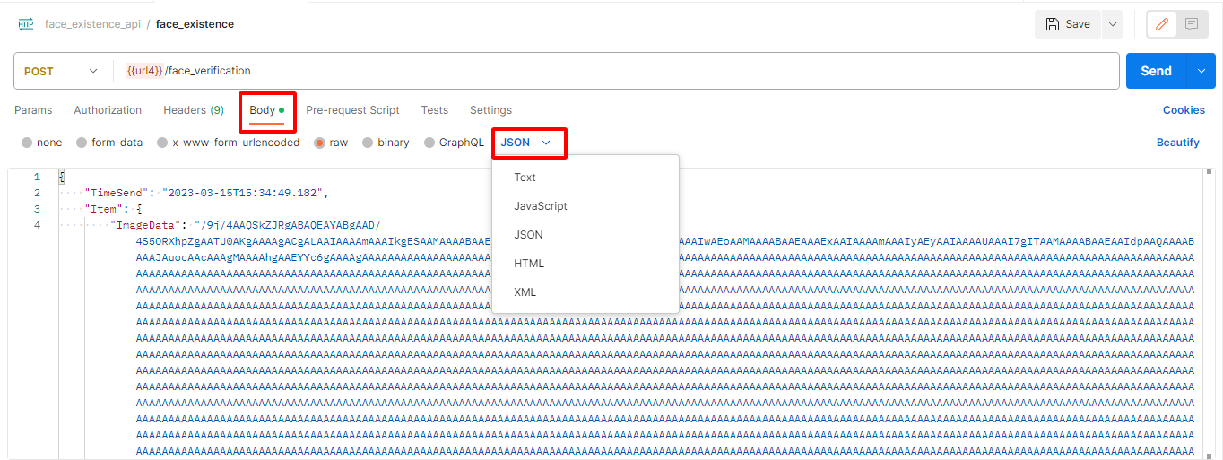

Figure 49. Set request format as JSON in Postman.

1. In case the API request require the Base64 image format, whenever we convert an image file (.jpg, .png) into Base64 on the webapp, there is always a tag before the comma `,` **delete this tag**. For example:

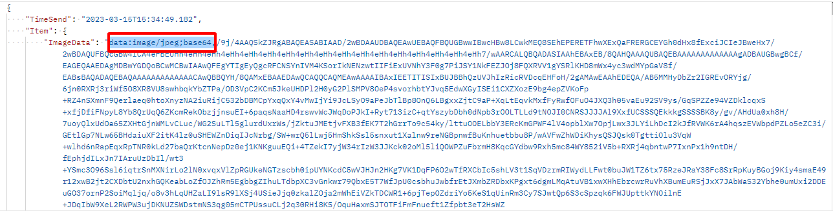

Figure 50. Delete the base64 data tag before comma `,`.

Manual testing with Postman is not a job that requires high technical skills; however, this job requires a great deal of patience to probe and find the limitations of the AI system that an organization is having.

Beside that, in the AI niches, using postman manual test can help us to see if our AI in the Software System working “intelligent” enough. For example, registering a face with a real camera, to see which camera angles have limitations in capturing and recognizing a person's face; triggering with more and more creative ideas, …

Don't hesitate to bring crazy ideas into our test cases, artificial intelligence can get right from point A to point B and predict future results thanks to its ability to learn quickly and infinitely. However, lacking the creativity and madness of humanity, AI only stagnates after many times of training.

We can take a look by accessing [here](https://www.notion.so/AI-supports-improving-recognition-features-227d0d99077143a79ef59b59748e5308?pvs=4) to see a small report sample test with Postman during the working scope in reporting API test for ITD group.

Besides, executing manual tests with Postman also helps us understand the basic testing process, creating a foundation for understanding to write algorithms for Unit Tests.

Deploying Unit Test makes testing easier and more automated, for example, a good software system should pass all the difficult tests that the test engineer team has set before releasing a new version. Creating a code skeleton for further testing purpose between company’s departments, for example scalability testing, CI/CD, Security, …

Therefore, in the following sub-section, we will see how to implement several codes for unit testing through the information we got through the API description documentation and Postman manual testing.

### Unit Testing with Pytest and an example of Scalability testing:

The source code of this part is private and protected by the law of ITD Group, therefore this thesis will show the readers needed algorithms and how to implement it into Pytest in the most basic ways:

1. After implementing manual test and reading the documentation carefully, we realize that in order to implement a request for testing it is necessary to have a base64 image and real time for testing, let’s import several necessary libraries.

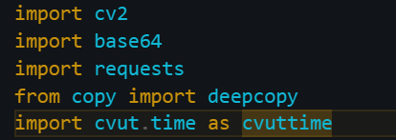

Figure 51. Libraries for Unit Testing with Postman.

1. Next, we need to fetch the API URL for sending a request to company server by declare several variables, for example:

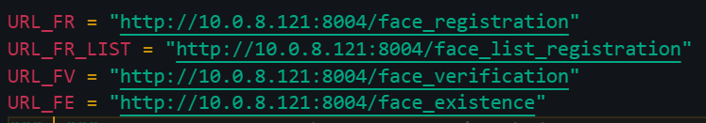

Figure 52. Declaring the variables for API url.

1. Next, we will define a function to convert the images into Base64 format by the **`base64`** library that we have imported and then declare several image variables that is decoded into Base64, for example:

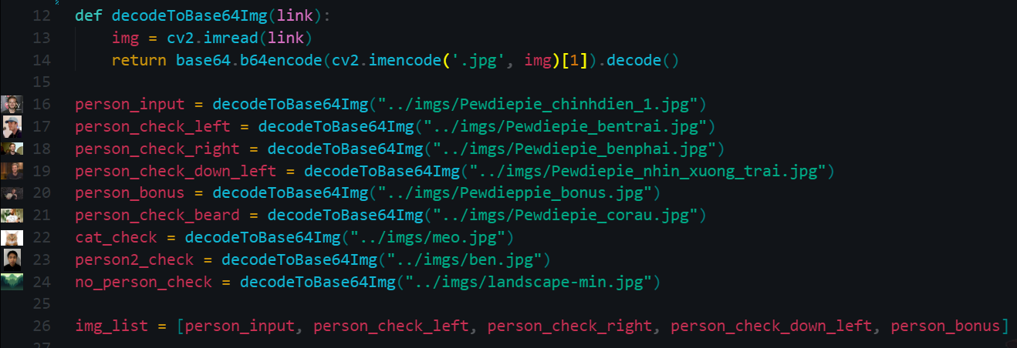

Figure 53. Define a function for decoding our images into Base64. Simultaneously, declare base64 image variables.

1. (Optional) As we need our code to be short, effective, and reusable, it is necessary to declare template variables contains the request data to send to the system and then whenever we request a message, just need to inherit them with the data (such as Person image) we want to send, for example:

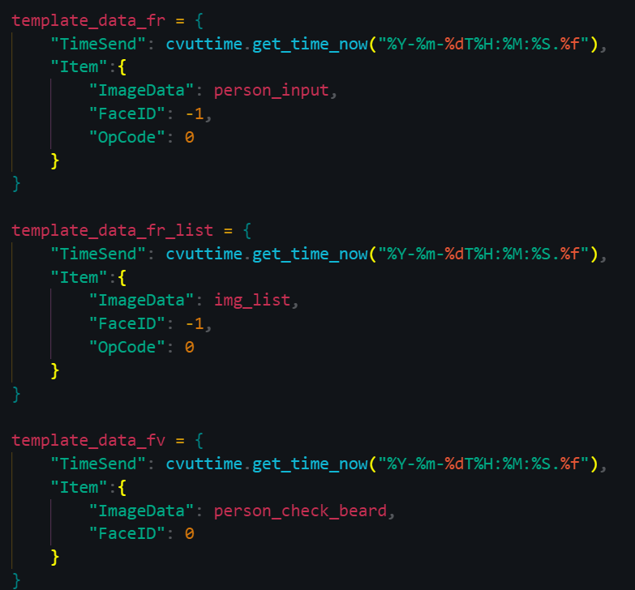

Figure 54. Declare template data variables

1. Implement the first test, here we will use the `**deepcopy`** module from imported **`copy`** library to copy the template we declare before. (Take the template `**template_data_fr**` for face registration data). Then modify the image data that we want to request, remember to change our request and response data into JSON format. After all, use module **`assert`** of Pytest to evaluate the test result if it passed or not. For example:

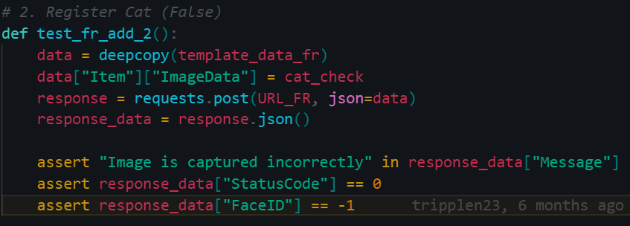

Figure 55. Test case registering a cat into the face recognition system.

1. Last but not least, let’s run the test case with the following CLI command ` **pytest [file_path]::[test_case]**`. For example:



Figure 56. CLI command for test our test case

By implementing some of the basic testing algorithms knowledge above, we can apply Unit Testing in writing test in more cases.

For example, in scalability testing, the using of manual testing of hundreds or thousands of images is very time-consuming. We can use Pytest to do this quickly by declaring an array of hundreds or thousands of images, then use a loop to perform create, read, update, delete (CRUD) tasks. Let’s go here for the algorithm idea of scalability test.

* **Step 1:** Create 2 folders, the first one named face_registration_multiple_create with 2 files inside as `face_list.py` and `face_registration_test.py` and the other one is `imgs` where contain the person face images data:

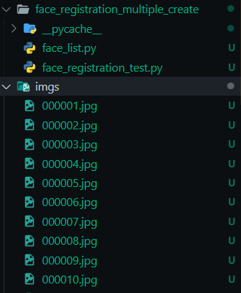

Figure 57. Folder structure for scalability test

* **Step 2:** In the file `face_list.py` we declare 2 different face list, the face_list2 is the face_list1 but the element inside is randomly shuffled. This helps us to save time and save the machine resources.

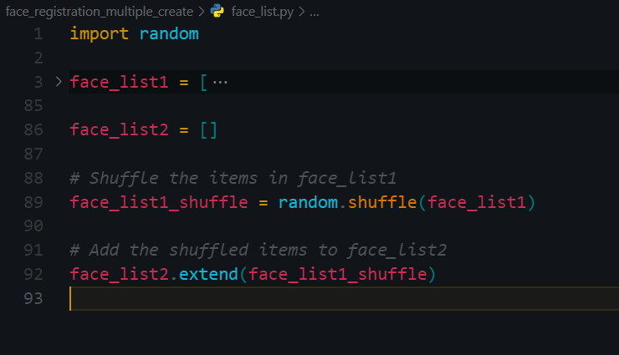

Figure 58. Declare different face list for scalability test.

* **Step 3:** In the file `face_registration_test.py`, let’s modify our testing logic. Firstly, import Libraries: The code begins by importing necessary libraries, including **base64, requests, cvut.time, face_list, and pytest**. These libraries provide functionality for encoding images to base64, making HTTP requests, handling timestamps, and running pytest tests. Also, we declare the URL_FR variable for fetching to the Face Registration URL of ITD:

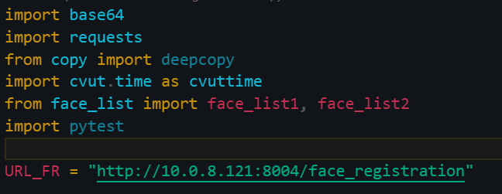

Figure 59. Import libraries and define API endpoint.

* **Step 4:**  Define **encodeToBase64Img** function to take an image file path as input, reads the image, encodes it to base64 format, and returns the encoded string. It's used to prepare images for registration in the tests.

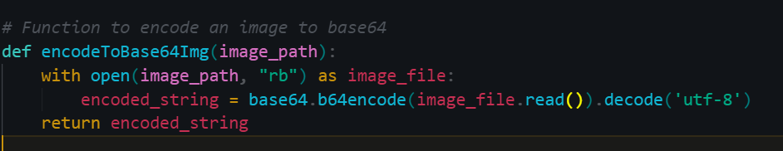

Figure 60. Define encodeToBase64Img function for scalability testing

* Step 5: Test Registration of Multiple Faces with **`test_registration_multiple_faces`** function with the following steps:
  + Initializes an empty list face_ids to store the registered face IDs.
  + Iterates over a list of image file paths (face_list1), representing multiple faces to be registered.
  + For each image, it encodes the image to base64.
  + Constructs a JSON payload with the image data, OpCode, and FaceID.
  + Sends a POST request to the registration API.
  + Asserts that the response indicates success, has a StatusCode of 1, and that the returned FaceID matches the expected value (based on the iteration).
  + Stores the registered FaceID in the face_ids list.
  + The test concludes by verifying that all expected FaceIDs were registered.

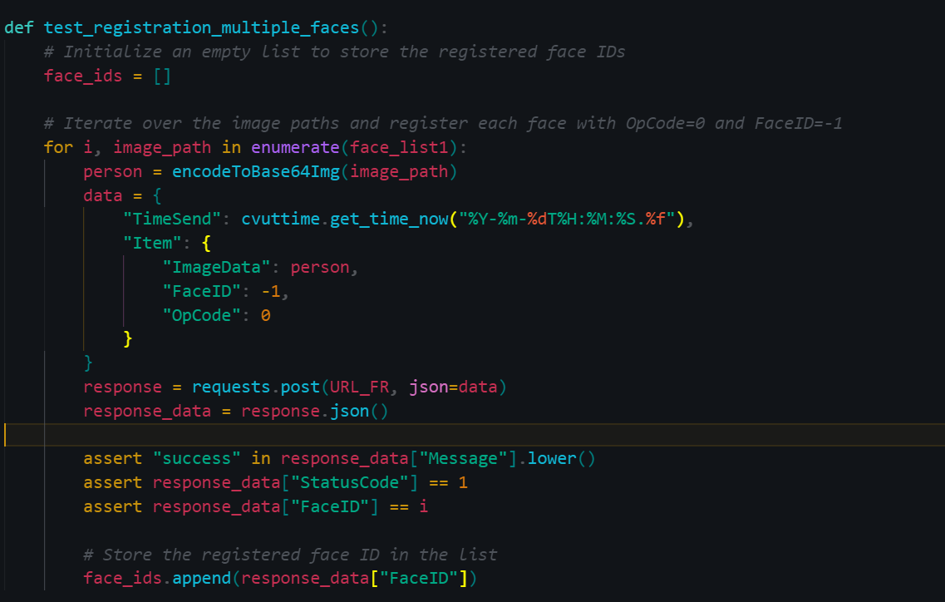

Figure 61. Define `test_registration_multiple_faces` function for scalability testing.

* Step 6 - Test Update of Multiple Faces: The `test_update_multiple_faces` function is similar to the registration test but focuses on updating existing faces. It iterates over a list of image file paths (face_list2) which we random shuffled before and updates each face with an OpCode of 1. It also verifies the response.

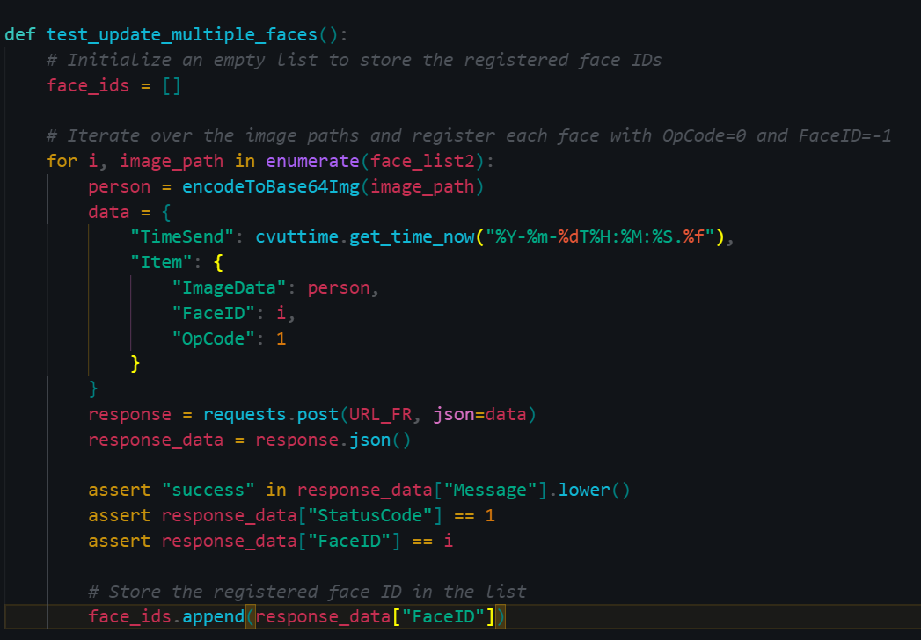

Figure 62. Define `test_update_multiple_faces` function for scalability testing.

* Step 7 - Test Deletion of Multiple Faces: The `test_delete_multiple_faces` function tests the deletion of multiple faces. It iterates over the FaceIDs of previously registered faces and sends a request to delete each face with an OpCode of 2 (mentioned by the ITD’s document). It verifies that the deletions were successful. This work also ensures that the database of company is returned empty after implementing our test to Avoid resource capacity to become overflow.

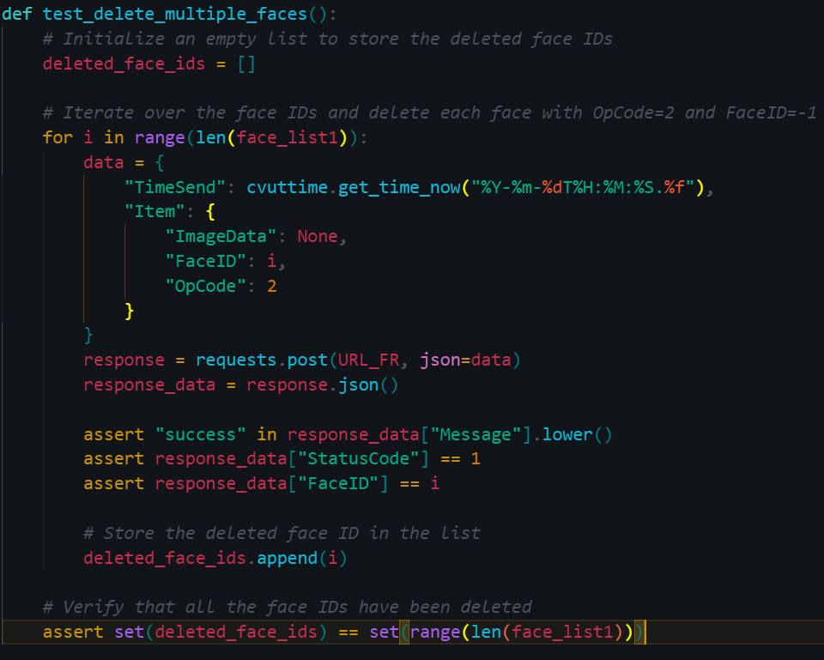

Figure 63. Define `test_delete_multiple_faces` function for scalability testing.

The purpose of scalability testing is to evaluate how a system performs as it scales to handle an increasing load or number of users, ensuring the system remains responsive and stable as demand is increasing.

## Writing script test for object tracing feature:

Writing a test script requires a test engineer to act as the end user of the proposed product. In this situation, our product is related to security issues, so we should put ourselves in the perspective of a building security guard to better understand the issues when using software to perform administrative work.

This script test is implemented by the requirement of ITD Software department. However, this task is also a good example for broadening the knowledge of an AI Test Engineer.

Main goal: To verify that the AI API tracing feature for the Camera system at ITD building works as expected.

* **Prerequisites:**
  + The smart camera system is installed and configured properly.
  + AI API for smart camera system is installed and configured.
  + AI API tracing feature is enabled.
* **Testing step:**

1. Start the smart camera system and make sure it works normally.

2. Open the AI API interface and navigate to the tracing feature.

3. Configure trace settings, including trace duration and traced objects.

4. Start the tracking and verification feature of the specified object by clicking on the specific ID or image displayed on the tracing interface (further, we can click on the object that needs to be traced in streaming cam).

5. Interrupt the tracing feature and verify that it stops capturing objects.

6. Save the traced objects to a file and verify that the file is saved correctly.

7. Open the traced objects file and verify that the traced objects are represented correctly.

8. Repeat steps 3-7 with different tracking settings and objects to be traced.

9. Disable tracing and verify that it is no longer capturing objects.

* **Expected result:**

1. AI API's tracking feature will accurately capture the specified objects. Once the object is clicked, the entire camera system will identify the object in real time.

- In case of Streaming camera: The tracking screen will continuously switch camera views to clearly show the moving location of the identified object within the building's premises.

- In case of camera recording: After identifying the subject, users of the camera monitoring system will be allowed to access image and video data files, files that AI thinks the stored objects have. Similarity to the subject determined that day (In case of a person going to work, not changing clothes, external appearance does not change too much). Here we can set a time limit for the tracing API's review system, to ensure the AI works with the highest accuracy. (Time frame limit can be up to 24 hours from the time the object appears or longer for larger time frames).

2. Tracking will stop capturing objects when interrupted.

3. The traced object file must be saved properly and accurately represent the traced objects.

4. Tracing will stop capturing objects when disabled.

If any of the above steps or expected results fail, the tracking feature of the AI API for smart camera systems will be further investigated and fixed.

* **Features that can be integrated into the tracking/tracing object feature:**

**1. Real-time alerts:** AI API can be configured to send real-time alerts to security personnel or building managers when a traced object is detected in a restricted area or is behaving suspiciously. This can help prevent security breaches or other incidents.

**2. Object recognition:** In addition to tracking people, the AI API can be configured to track other objects of interest, such as vehicles, packages, or devices. This can help improve inventory management or prevent theft.

**3. Analyze historical data:** The AI API can be configured to analyze historical data to identify patterns or anomalies in the movements of tracked objects. This can be useful in identifying areas of the building that are frequently accessed or identifying potential security risks.

**4. Integration with other systems:** AI API can be integrated with other systems, such as access control systems or building automation systems, to provide a more comprehensive view of building operations and security. For example, the AI API can be configured to automatically unlock doors or turn on lights when a tracked object enters a room.

Writing script test for object tracing feature (as example) in an AI Video Management System (VMS) offers numerous benefits:

1. **Quality Assurance:** Script tests help ensure the quality and reliability of the object tracing feature. By systematically validating tracing behavior, we can identify and address issues early in the development cycle.
2. **Early Issue Detection:** Detect and address tracking issues before they impact users, reducing the risk of unexpected behavior.
3. **Reliability:** Ensures that the object tracing feature works consistently and reliably across different scenarios.
4. **Documentation:** Test scripts serve as documentation for expected tracing behavior, making it easier for AI and IT teams to understand requirements.
5. **Regression Testing:** Detects regressions caused by code changes in other parts of the system, ensuring tracing remains functional.
6. **Scalability:** Scales with the VMS to handle more cameras and scenarios, ensuring tracing accuracy at scale.
7. **Continuous Integration:** Integrating script tests into CI/CD pipelines automates testing and ensures tracing functionality is validated with each code change.
8. **Cost Saving:** Identifies and resolves issues early, reducing the need for extensive manual testing and troubleshooting.
9. **Confidence:** Builds confidence in the reliability and correctness of object tracing, enhancing user satisfaction.
10. **Compliance:** Helps demonstrate compliance with industry standards and certification requirements.
11. **Advanced Features:** Allows integration of advanced features like real-time alerts, object recognition, historical data analysis, and integration with other systems for a more comprehensive security solution.

In summary, script tests for object tracing improve the AI Video Management System's quality, reliability, and efficiency, ensuring it satisfies user expectations and industry requirements while enabling additional security features.

## Conclusion:

In conclusion, Chapter 4 of this thesis stands as a guiding light for the next generation of AI testing engineers, poised to navigate the intricate landscape of AI and APIs. Drawing inspiration from the real-world scenario at ITD, this chapter imparts invaluable wisdom and strategies that will empower these future engineers to excel in our roles.

At its core, this chapter underscores the paramount importance of holistic understanding. AI testing engineers must transcend traditional roles, immersing themselves in AI workflows, evolving into champions of software quality and user satisfaction.

Independent thinking is emphasized. AI testing engineers must stand with end-users, fearlessly pointing out defects, ensuring AI systems meet the highest standards—an essential trait of a great AI tester.

Practical testing comes alive with insights into manual testing via Postman and automated unit testing using Pytest. These are not just tools; they are powerful instruments. Understanding API documentation becomes a superpower, enabling meticulous AI system validation and effective issue reporting.

Efficiency thrives here. Valuable tips optimize manual testing with Postman, fostering a clean workspace, organized collections, and smart URL environments. These tips save time and boost efficiency.

Unit testing with Pytest is demystified step by step, paving the way for automating testing, ensuring robust software quality—a skill essential for AI testers.

The piece of resistance is the exploration of script tests for object tracing in AI Video Management Systems. These tests offer a treasure trove of benefits, from enhancing quality to ensuring scalability and compliance. They empower AI testing engineers to instill confidence in AI systems, making them impeccable, not just functional.

In essence, Chapter 4 is a rite of passage for future AI testing engineers, equipping them with knowledge, mindset, and tools. It prepares them to usher AI systems into a future where excellence is a necessity. It ignites a passion for AI testing that will drive innovation, elevating AI engineering standards for generations to come.

# Conclusion and Future Work.

(Will be written after receiving the first feedback of phase 1/3)

## Contribution to the field of Video Management System with AI capabilities.

## Limitations of the thesis and future work.

# references

[AI For Everyone Coursera course.](https://www.coursera.org/learn/ai-for-everyone/home/week/1)

[AI Testing 101.](https://www.perfecto.io/blog/testing-ai)

[Python for Data Science, AI & Development.](https://www.coursera.org/learn/python-for-applied-data-science-ai)

[Python Testing with Pytest.](https://learning.oreilly.com/library/view/python-testing-with/9781680509427/)

[API Testing and Development with Postman.](https://learning.oreilly.com/library/view/api-testing-and/9781800569201/)

[Test-driven development.](https://en.wikipedia.org/wiki/Test-driven_development)

[Software testing strategies.](https://www.geeksforgeeks.org/software-testing-strategies/)

**APPENDIX 1**

**Thesis passport** (to be given to the supervisor for filing after the thesis is finished). **N.B. Wihi platform can be used for monitoring as well.**

Name of student ___________________________________

Group _____________________

Contact information________________________________________________________________

Topic of thesis ___________________________________________________________________

Client __________________________________________________________________________

At latest Date Signature

1. Introduction to thesis and related assignments completed

_______ _______ ________________

1. Approval of topic _______ _______ ________________
2. Thesis plan approved _______ _______ ________________
3. Interim seminar presentation held ________ _______ ________________
4. Contents of thesis approved ________ _______ ________________
5. Layout and language approved ________ _______ ________________
6. Abstract in foreign language accepted ________ _______ ________________
7. Thesis submitted to the opponent ________ _______ ________________
8. Participation in presentation seminars

- excluding acting as an opponent and own presentation

1. ______________________________________ _______ ________________

2. ______________________________________ _______ ________________

3. ______________________________________ _______ ________________

4. ______________________________________ _______ ________________

5. ______________________________________ _______ ________________

6. ______________________________________ _______ ________________

1. Presentation of own thesis held _______ ________________
2. Acting as an opponent (title/student)

____________________________________ _______ ________________

1. Maturity test accepted _______________________

1. I hereby assure that I saved my thesis in electronic form into Theseus at the address

________________________________________________________________________

Address Signature of the student

APPENDIX 2

**APPENDICES**

You can enclose as appendices for example a questionnaire used in the study or other material that is related to the study.

Material that the client wished to classify can be enclosed as an appendix; in this case, the appendix is not included in the published version submitted to Theseus or in the hardbound version.

**THE TITLES AND NUMBERING OF APPENDICES**

The appendices are numbered and given a title. When you refer to an appendix in the text, use the correct referencing practice. Remember to mention the number of the appendix.

Table 3. Thesis Assessment Criteria

|  | **Excellent (5) - Very good (4)** | **Good (3)** | **Satisfactory (2) - Passable (1)** | **Fail 0** |
| --- | --- | --- | --- | --- |
| **Choice of topic** | The topic is significant and current with regard to  developing the field of study. The topic meets the need of the client from the working life. With respect to the choice of topic, the student is able to question and justify the development needs in his/her field of study. The topic is, from the point of view student's professional knowledge, skills and qualifications, innovative and opens up new perspectives in working life. | The topic meets the needs of the client. With respect to the choice of topic, the student has an understanding of the development needs in his/her field of study and is able to analyse them and present them in logically. The topic develops the student's professional knowledge, skills and qualifications and is challenging | With respect to the choice of topic, the student recognises the development needs in the field. The topic corresponds to the student's professional knowledge, skills and qualifications. The topic develops the student's knowledge and skills, and the student is able to justify in what way | The choice of the topic is not based on the proven needs of the working life nor to the development of the field of study. The minimum requirements of Polytechnic Degree (EQF 6) are not me |
| **Knowledge basis** | The student has built up the knowledge basis of selected diverse sources that are relevant to the topic. S/he is able to make syntheses and draw conclusions logically based on the material. The student uses and defines the concepts in a diverse way and with the thesis creates new usable theory in the field. | The student recognises the phenomenon/topic showing expertise in the field. The use and definition of concepts is analytical and justified. The student has built up a wide knowledge basis using reliable sources. The student defines the phenomena critically, diversely and creating new perspectives. | The student's acquaintance with the topic is good but narrow. A more wide approach would be needed in the understanding and definition of concepts. The knowledge basis is narrow. The use of sources is wide but making syntheses and analyses and drawing conclusions based on the sources has proved out to be difficult. | The knowledge basis is incomplete, narrow and invalid. The minimum requirements of Polytechnic Degree (EQF 6) are not met. |
| **Implementation** | The student finds the essential questions of the topic/problem in a creative way and restricts the problems in a justified and logical way. The student has found the appropriate methods to approach the topic and manages them well. The student's expertise can be seen in the process as well as the sharing of the expertise with the co- operation partners. The student assesses his/her work process analytically and shows a capability to develop. | The student recognises the essential questions regarding the topic and restricts the problem successfully with regard to the topic and the requirements of the thesis. The student uses methods appropriate to the topic and shows that s/he manages them. The student works autonomously but is also able to do constructive co-operation with other parties. The schedule and work process is managed. The student's approach to the thesis shows initiative, development ability and reflection. | The student recognises relevant questions regarding the topic/problem but the restriction of the problem is vague. The methods applied are conventional and their management according to the given model. Keeping the schedule and following the plan is difficult. The student finishes the thesis in accordance with the objectives and showing expertise. | The approach is clearly insufficient and the thesis is not finished in the agreed schedule or at all in spite of instructions and guidance. The knowledge basis, methods and implementation do not have valid connection. The minimum requirements of Polytechnic Degree (EQF 6) are not met. |
| **Analysis and discussion of results** | The results show expertise that is interesting from the viewpoint of the development in the field. The student is able to analyse complex problems, utilising the knowledge basis, in a new way and make a feasible application out of the results serving the working life (new perspective, innovation, advancement of the field). The student is able to form a clear opinion and a model of further action and development needs in the field and to justify them. | The student is able to apply wide knowledge basis successfully in solving the problem in the field of specialisation. The student is able to critically view the results, theories and methods used. The student is able to apply the results and suggest further action relevant to the working life and the field. S/he is able to define the development needs concerning knowledge and skills in the field. | The results of the thesis meet the objectives on most parts. The student is able to view the results critically and assess his/her own skills and expertise with respect to the objectives but superficially. The student is able to suggest further action and development, meeting the basic requirements regarding the skills and knowledge in the field. | The results do not have any relation to the problem, theory or methods. The results cannot be applied to develop professional practices. The critical assessment of the results is insufficient.  The minimum requirements of Polytechnic Degree (EQF 6) are not met. |
| **Reporting** | The report shows interesting expertise with regard to the development of the field. The report shows excellent mastery of the language and it conveys the student's thinking clearly and in a logical and illustrative way. The language is flawless and business style. The oral presentation is convincing and brings up the student's expertise well. | The student is able to present the results and conclusions analytically, illustratively and with good reasoning. S/he can communicate the results successfully to various interest groups showing critical thinking developing expertise. The language is flawless and business style. The oral presentation is illustrative and directed to the target group | The student follows the reposting instruction issued by the UAS. The report is structured and the language fairly good business style. The oral presentation is structured and concentrates on the presentation of the contents. | The reporting instructions have not been followed. There are flaws in the language and structure. Plagiarism can be detected in the report. The minimum requirements of Polytechnic Degree (EQF 6) are not met |